|  |
| --- |
| The University of hull |
| LoRaWan |
| [Document subtitle] |

|  |
| --- |
| Ieaun Roberts  [Date] |

# Abstract

Original Project Description

“This project aims to produce a LoRaWAN gateway that is able to secure private data whilst still allowing the gateway to route public data to The Things Network.

Public users commonly utilise 'The Things Network' (TTN) to connect endpoints and gateways. The more of these that are available, the more useful and usable LoRaWAN is for all. However, private companies are often uncomfortable with their data being shared with third parties. This drives them to create their own LoRaWAN infrastructure and not connect their gateways to TTN.  
  
This project seeks to offer public connection to TTN but gateway-level private filtering for registered endpoints. Data from unregistered/unknown endpoints is still sent to TTN as usual. Private data is filtered out and not sent to the TTN servers - instead the data would be sent to privately owned servers for storage/use. This means that protected data is secured whilst ensuring that the gateway is still useful to the public.”

Contents

Abstract 1

1. Introduction 3

1.1. Background 3

1.2. Problem 3

1.3. Purpose 3

1.4. Goal 3

1.5. Ethics 3

1.6. Outline 3

2. Aims and Objectives 4

3. Background 5

What is LoRa ? 5

What is LoRaWan 6

Use cases 8

Hardware systems 10

LoRaWan gateways and end nodes 10

Technical background 1

4. Development 2

5. Project management 2

5.1. Time plan 2

Task list 2

5.2. Project risks 2

6. Critical evaluation 2

Definition of done 2

Technical achievements 2

Problems faced; lessons learnt 2

7. Conclusion 3

8. Appendix 4

Appendix 1.1: Original topic description 4

Appendix 1.2: 0

Notes 0

9. References 14

# Introduction

## Background

## Problem

## Purpose

## Goal

## Ethics

## Outline

# Aims and Objectives

1. Initial system set up phase:
   1. Conduct extensive research into the topic:
      1. Propagation and Fresnel zone
         1. Link budgets and margin
      2. LoRa chips and devices for end nodes.
      3. LoRaWan chips and devices for gateways.
   2. End nodes:
      1. Setup a system in which two LoRa end nodes are able to communicate with one another.
         1. One in the role of an end node (sending data to the gateway).
         2. One in the role of a gateway (receiving the data and forwarding it to TTN)
      2. Document short comings and improvements to understand the justifications for a gateway.
   3. Gateway:
      1. Produce a LoRaWan gateway that is capable of receiving communications from multiple end nodes.
   4. Add functionality:
      1. Enable it to forward packets received to:
         1. The TTN
         2. Private servers
      2. Differentiate between public and private packets.
      3. Option to encrypt packets.
   5. Produce a LoRaWan gateway that is able to secure private data whilst still allowing the gateway to route public data to the things network.
2. Exploration of use cases / experiments phase:
   1. Examine each of the outlined use cases and produce several experiment results on selected use cases.
      1. Outline short comings.
      2. Research possible improvements.
      3. Security concerns.
3. Further development phase:

# Background

## What is LoRa ?

“LoRa (Long Range) is a low-power wide-area network protocol developed by Semtech. It is based on spread spectrum modulation techniques derived from [chirp spread spectrum](https://en.wikipedia.org/wiki/Chirp_spread_spectrum) (CSS) technology.

LoRa uses license-free sub-gigahertz [radio frequency](https://en.wikipedia.org/wiki/Radio_frequency) bands like 433 MHz, [868 MHz (Europe)](https://en.wikipedia.org/wiki/Short-range_device#SRD860), 915 MHz (Australia and North America) and 923 MHz ([Asia](https://en.wikipedia.org/wiki/Asia)). LoRa enables long-range transmissions (more than 10 km in rural areas) with low power consumption.

The technology covers the [physical layer](https://en.wikipedia.org/wiki/Physical_layer), while other technologies and protocols such as LoRaWAN (Long Range Wide Area Network) cover the upper layers.”

-Wikipedia (Wiki, 2020)

Speed (0.3 – 5.5 kbps) - mobilefish

LoRa spread spectrum is a patented modulation technique developed by semtech based on spread spectrum modulation. LoRa provides long-range and low power consumtion, a low data rate and secure data transitions. LoRa can be used with public/private and hybrid networks to achieve a greater range thjan cellular networks

LoRa’s range is largely dependent on the environment of its use case and the materials used within.

|  |  |
| --- | --- |
| Environment | Range (km) |
| Urban | 2-5 |
| Rural | 5-15 |
| Direct line of sight | >15 |

Record: 436 miles / 702Km, Weather balloon to ground connection (TTN, 2017)

Lora Node

Usually battery powered device making use of a sensor. Sensor data is transmitted to a gateway.

Lora Gateway

* Connected to the internet,
* receives data from end nodes.
* Multiple end nodes can receive the same data.
* Gateways can listen to multiple frequencies simultaneously

LoRaWan protocol does not support direct communication between end nodes. Need to use Radiohead if you want to do this.

Lpwan – Low Power Wide area network, wireless communication for sending small data packages over long distances usually powered by battery. Technologies include Narrowband IoT (NB-IoT), Sigfox, lora and others

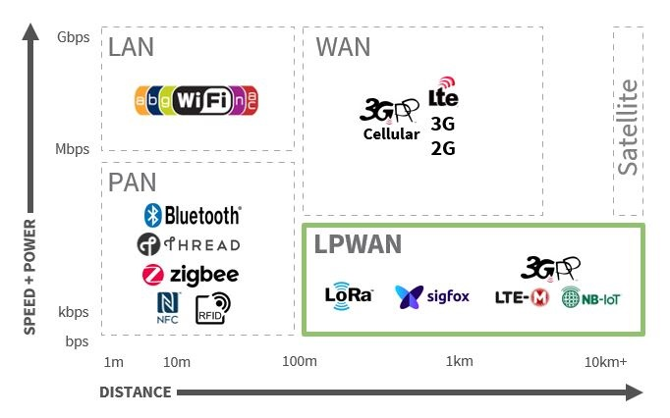

**Figure , Wireless technologies.**

## What is LoRaWan

“Since LoRa defines the lower physical layer, the upper networking layers were lacking. LoRaWAN is one of several protocols that were developed to define the upper layers of the network. LoRaWAN is a cloud-based [medium access control](https://en.wikipedia.org/wiki/Medium_access_control) (MAC) layer protocol but acts mainly as a network layer protocol for managing communication between [LPWAN](https://en.wikipedia.org/wiki/LPWAN) [gateways](https://en.wikipedia.org/wiki/Gateway_(telecommunications)) and end-node devices as a routing protocol, maintained by the LoRa Alliance.

LoRaWAN defines the communication protocol and system architecture for the network, while the LoRa physical layer enables the long-range communication link. LoRaWAN is also responsible for managing the communication frequencies, [data rate](https://en.wikipedia.org/wiki/Data-rate_units), and power for all devices.

Devices in the network are asynchronous and transmit when they have data available to send. Data transmitted by an end-node device is received by multiple gateways, which forward the data packets to a centralized network server.[[11]](https://en.wikipedia.org/wiki/LoRa#cite_note-:0-11) The network server filters duplicate packets, performs security checks, and manages the network.

Data is then forwarded to application servers.[[12]](https://en.wikipedia.org/wiki/LoRa#cite_note-12) The technology shows high reliability for the moderate load, however, it has some performance issues related to sending acknowledgements.”

-Wikipedia (Wiki, 2020)

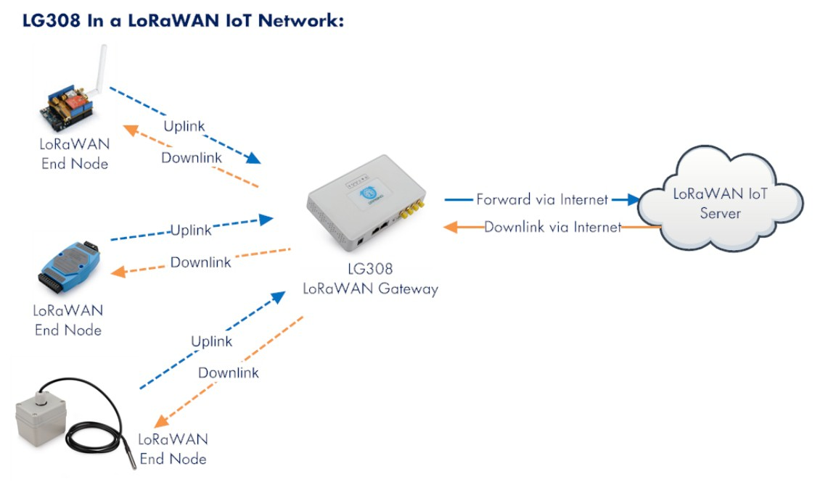

**Figure , LoraWan IoT Network** (Antratek, 2020)

## Use cases

#### Smart utilities

Automated Meter Reading.

Home and Building Automation.

#### Health and hygiene

#### Safety

Off grid mobile phone messaging (Skrypt, 2019)

Wireless Alarm and Security Systems.

#### Efficiency

Industrial Monitoring and Control

#### Agriculture

Long range Irrigation Systems

#### Other

IP over LoRaWan (Cola, 2018)

Lora operates in the unlicensed ISM bands (Industrial, scientific and medical) used for purposes other than telecommunication, it is possible to view a more in depth breakdown of specific frequencies in LoRa per country by visiting <https://www.thethingsnetwork.org/docs/lorawan/frequencies-by-country.html>

In Europe use of the ism bands are limited to 0.1% and 1% duty

Max antenna gain is +2.15 dbi

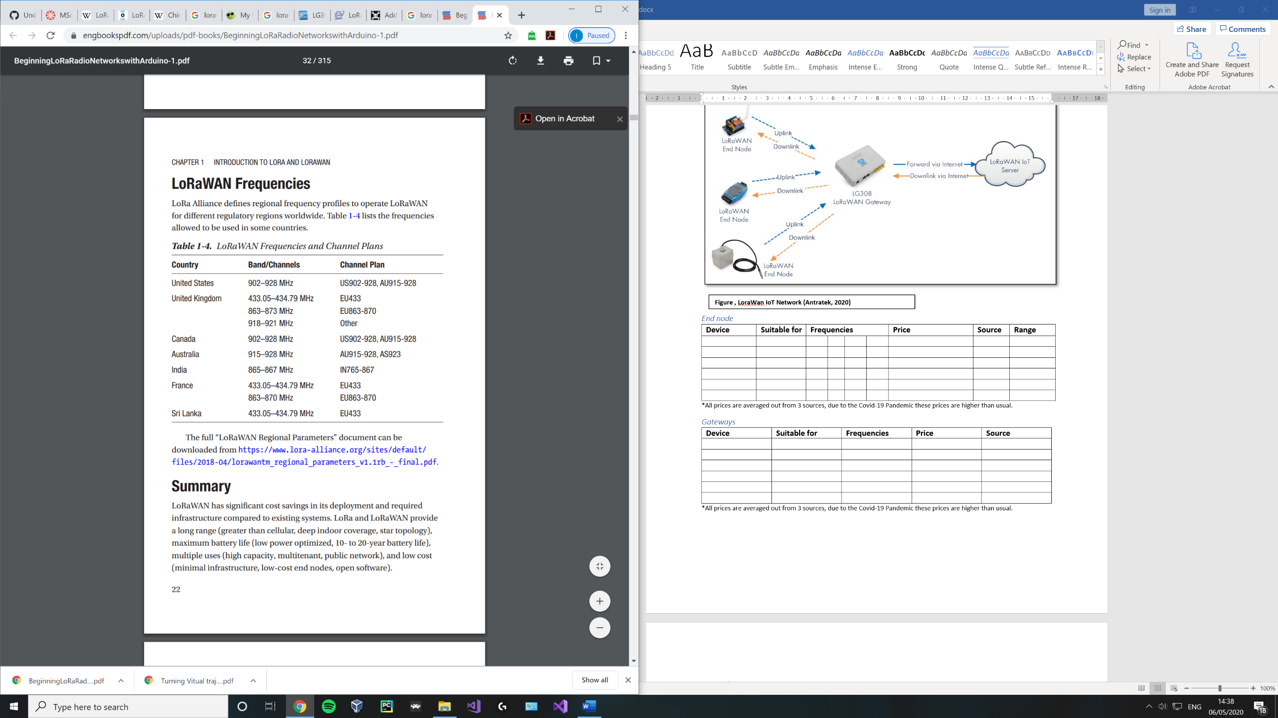

**Figure , LoraWan IoT Network (Seneviratne, 2019)**

#### The things network

Fair use policy limits user:

* uplink airtime to 30 seconds per 24 hours per node
* downlink messages are limited to 10 messages per 24 hours per node

|  |  |  |  |  |  |  |
| --- | --- | --- | --- | --- | --- | --- |
| Technology | Peak data rate | Bandwidth | Range/ Penetration | Duplex mode | Power consumption | Price |
|  | <100kbps | 200 KHz | Low | Half | Low | £ |
|  | Up to 1Mbps | 1.4 MHz | Medium | Full/Half | Meduim | ££ |
| LTE-Cat-1 | Up to 10Mbps | 20 MHz | High | Full | High | £££ |
|  |  |  |  |  |  | £ |
|  |  |  |  |  |  |  |
|  |  |  |  |  |  |  |

(electronicspecifier, 2020)

## Hardware systems

#### LoRaWan gateways and end nodes

Due to the cost of particular devices, some may only be feasibility in certain use cases. In this section end nodes and gateways are split into 2 sub sections, being either for use in small scale projects (with a price cap of x amount **overall\***) or industry use (with no price cap).

Semtech has licenced the LoRa ip to a handful of chip manufacturers such as HopeRF, Rak and Microchip.

(semtech, n.d.) (dragino, 2019) (Supply, n.d.)

##### End Nodes

Functionality expected from an end node.

What alters the price of an end node ?

1. Type of microcontroller it is designed for.
2. Type of LoRa radio module chip used.
3. Type of antenna included / antenna connector included.
4. Presence of additional sensors on the device.

**Figure , RAK811 system diagram** (RAK, n.d.)

##### End node chips

|  |  |  |  |  |  |  |
| --- | --- | --- | --- | --- | --- | --- |
| **Manufacturer** | **Chipset** | **Max**  **Power amplifier** | **Max link budget** | **Sensitivity (dBm)** | **Remarks** | **Image** |
| Microchip | RN2483 | +14 dBm |  | -146 | * Ability to alternate between 433/868 frequencies. * Class A. |  |
| Semtech | SX1276/ 77/78 /79 | +20 dBm | 168 | -148 |  |  |
| Semtech | SX1272/ 73 | +20 dBm | 157 | -137 |  |  |
| HOPERF / RF Solutions | RFM9xW | +20 dBm | 168 | -148 | * Based on SX1276 / 78. * Low cost. * Extensive datasheet. |  |
| Rak | RAK811 | +20 dBm |  | -148 | * Integrated with SX1276 and STM32L. * Class A and C. |  |

All values obtained from datasheets at the following locations:

Semtech: <https://www.semtech.com/products/wireless-rf/lora-transceivers>

Microchip: <http://ww1.microchip.com/downloads/en/devicedoc/50002346c.pdf>

HopeRF: <https://www.hoperf.com/data/upload/portal/20190301/RFM95_96_97_98W.pdf>

Rak: <https://doc.rakwireless.com/datasheet/rakproducts/rak811-lora-module-datasheet>

#### End node devices

|  |  |  |  |  |
| --- | --- | --- | --- | --- |
| **Device** | **Modules** | **Notes** | **Device** | **Price** |
| Dragino LoRa Shield | RFM95W | lower current consumption than competing devices. Temp sensor and low battery indicator. | Arduino | £20.27 |
| LORA CLICK | RN2483 |  |  | £42.05 (or £48.60 for 5) |
| I-NUCLEO-LRWAN1 | SX1272 | Accelerometer, humidity, magnetometer, pressure and temperature sensors | Arduino | £23.64 |
| Dragino Pi shield 113990254 | RFM95W | Lora/GPS | Raspberry Pi | £26.68 |
| Dorji (DRF1276DM) | SX1276 |  |  | £9.10 |
| DM164138 | RN2483 | All in one device with built in sensors / LCD. |  | £56.14 |
| RAK811 LPWAN | RAK811 | Arduino shield / stand alone device. | Arduino | £17.17 |
| RAK811 LoRa / Tracker Board | RAK811 | GPS, open source |  | £40.99 |
| pHat PIS-1128 | RAK811 |  | Raspberry Pi | £29.99 |
| Adafruit LoRa breakout | RFM96W | Breakout board |  | £15.12 |

*prices are illustrative only and were collected on +-13/05/2020, due to the Covid-19 Pandemic these prices may appear higher than usual.

#### Gateways

What alters the price of a Gateway ?

* Type of concentrator board used to receive LoRaWan packets.
* Type of antenna included / antenna connector included.

Functionality expected from a Gateway:

* Connection to an IP network (Wi-Fi/ Ethernet/ 4G).

Every gateway has a:

* Processor to demodulate a signal.
  + in the case of the SX1301, the chip can scan and detect packet preambles in 8 channels and simultaneously demodulate packets on all 8 channels. It is unable to scan and demodulate at the same time.
* One / two TX/RX radios (SX1255)

##### Gateway chips

|  |  |  |  |  |  |  |
| --- | --- | --- | --- | --- | --- | --- |
| **Manufacturer** | **Chipset** | **Max link budget** | **Sensitivity (dBm)** | **Remarks** | **Max end nodes** | **Channels** |
| Semtech | SX1301 |  | -142.5 (SX1256)  -139.5 (SX1255) |  | 10000 | 8 |
| Semtech | SX1308 |  | -139 (SX1255, SX1257) | 70db CW interferer rejection, | 10000 | 8 |
| Semtech | SX1257 |  |  |  |  |  |
|  | R11e- Lora8 |  |  |  |  | 8 |

All values obtained from datasheets at the following locations:

Semtech: <https://www.semtech.com/lora/lora-products>

##### Gateways devices

|  |  |  |  |  |
| --- | --- | --- | --- | --- |
| **Device** | **Chipset** | **Notes** | **Type** | **Price** |
| Mikrotik, LoRa8 | R11e- Lora8 | Listen Before Talk (LBT) and spectral scan features |  | £156.59 |
| The Things industries, TTIG-868 | SX1308  (Gateway) | USB-c, 900mA, LBT, Lora GW board, Basic station protocol | Indoor | £62.50 |
| TTN-GW-868 |  |  |  |  |
| Dragino LG01N/ OlG01N | SX1276/76  (x2 End node chips) | Single frequency, up to 300 nodes | Indoor/ outdoor  versions | £57.95 |
| Dragino LG02 |  | Full duplex, 2 channels |  |  |
| Cisco LoRaWan Gateway | SX1301  (x2 Gateway chips) | GPS, rich software features, 16 channels |  | £2055.21 |
| Kerlink IFemtoCell |  |  |  | £266.78 |
| Kerlink WirNet Station |  | 49 demodulators on 9 channels, bi directional. | outdoor | £1010.79 |
| Laird RG186 Sentruis | SX1301/SX1257 | Very popular gateway in the UK. | Indoor / outdoor | £220.80 |

*prices are illustrative only, due to the Covid-19 Pandemic these prices may appear higher than usual.

All values obtained from datasheets at the following locations:

Laird: <https://connectivity-staging.s3.us-east-2.amazonaws.com/2020-03/CS-PB-RG1xx-GATEWAY_v1_5.pdf>

Dragino:

Kerlink:<https://www.thethingsnetwork.org/forum/uploads/default/original/1X/1be8efc08586c0bb5676689df122a3628fe3e0e1.pdf>

The Things Industries:

Mikrotik:

Cisco:

##### Concentrator gateway cards

|  |  |  |  |
| --- | --- | --- | --- |
| **Manufacturer** | **Device** | **Remarks** | **Price** |
| IMST | iC880A-SPI - LoRaWan Concentrator |  |  |
| Mikrotik | R11e- Lora8 / R11e- Lora 9 | Based on SX1301 | £73.23 |

##### Overview of gateways in Hull, UK

##### What gateways are others using ?

|  |  |  |
| --- | --- | --- |
| **No** | **Brand / Model** | **Altitude (m)** |
| 1 | - | 150 |
| 2 | Raspberry Pi based, IMST | - |
| 3 | The Things Gateway | 34 |
| 4 | Raspberry Pi based, RAK831 | 1 |
| 5 | Raspberry Pi based, IMST | - |
| 6 | Raspberry Pi based 3 - 868.5Mhz | 8 |
| 7 | The Things Indoor Gateway | 3 |
| 8 | Mikrotik, LoRa8 | 15 |
| 9 | Mikrotik, LoRa8 | 5 |
|  | | |
|  | LoRa8 / raspberry pi IMST | 36 |

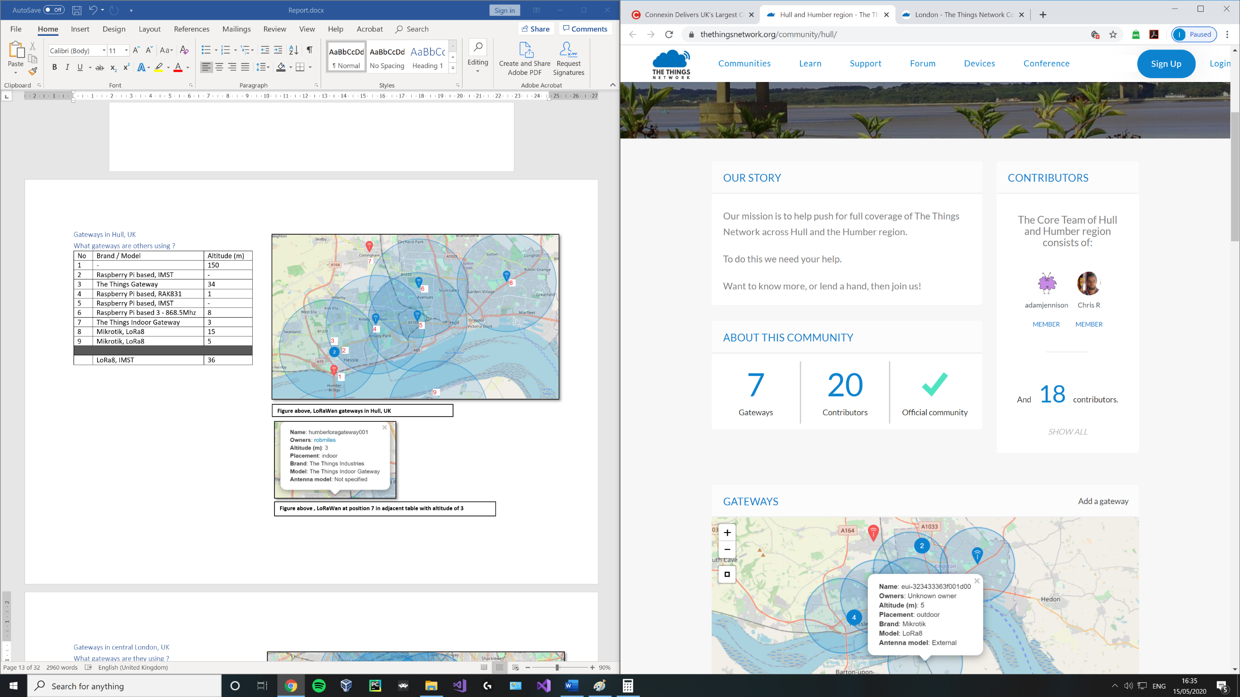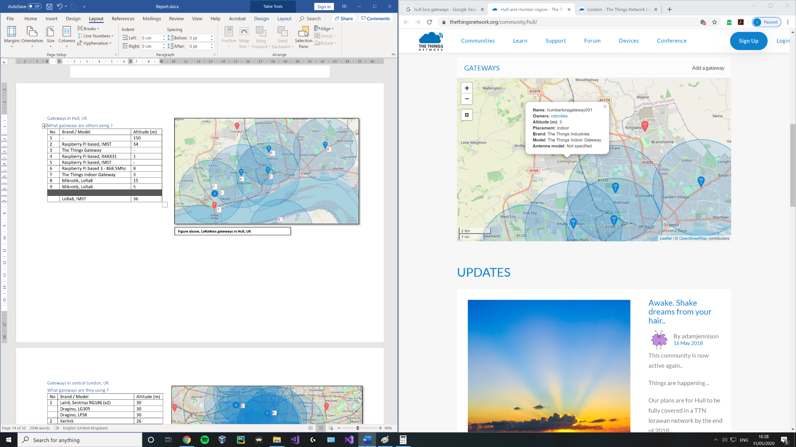

**Figure above , LoRaWan gateway at position 7 in adjacent table with altitude of 3**

**Figure above, LoRaWan gateways in Hull, UK**

##### Summary of Overview

|  |  |  |  |  |
| --- | --- | --- | --- | --- |
| **Location** | **Number of gateways** | **Number of contributors** | **Most common device** | **Average altitude** |
| **Hull** | 7 | 20 | LoRa8 / raspberry pi IMST | 36 |
| **London** | 59 | 61 | Kerlink | 43 |
| **Manchester** | 11 | 46 | Kerlink, Station | 46 |
| **Liverpool** | 32 | 22 | IOTLTD v. 10 | 58 |
| **Birmingham** | 2 | 38 | The Things Indoor Gateway | 20 |
| **Leeds and Bradford** | 20 | 40 | Kerlink, Station / MultiTech, Conduit | 92 |

* See [Appendix 1.2] for overview of gateways used in London, Manchester, Birmingham, Liverpool and Leeds / Bradford.

|  |  |  |
| --- | --- | --- |
| **Rank** | **Device** | **Count** |
| 1 | The Things Indoor Gateway | 11 |
| 2 | Kerlink Station | 7 |
|  | Laird, Sentrius RG186 | 7 |
| 4 | The Things Gateway | 4 |
|  | Raspberry Pi based, IMST | 4 |

*Only includes results where specific device name was provided.

*Number of gateways available and their altitude is constantly changing every day.

From the above overview of several cities in England, we can deduce the following:

1. **Cities that are considered tech hubs are dominated by Kerlink gateways in the UK.**

Kerlink was one of the initial players in the LoRaWan device market and its “Wirenet Station” holds the accolade of being the first LoRaWan gateway commercially available on the worldwide market launching in 2014. (kerlink, n.d.)

This predates both:

* The initial LoRaWan specification release by the LoRa Alliance in Jan 2015. (N. Sornin (Semtech), 2015)
* The Things Network launch in 2015. (wienkegiezeman, 2015)

Kerlink Wirenet Stations are carrier grade private gateways intended for industry customers. Prices for a single base station range from £1010.79 - £1470.75 and include robust software and access to Kerlink’s “ITalks” LoRaWan server.

## Technical background

Chirp spread spectrum

# Development

# Project management

## Time plan

## Task list

## Project risks

# Critical evaluation

## Definition of done

## Technical achievements

## Problems faced; lessons learnt

# Conclusion

# Appendix

## Appendix 1.1: Original topic description

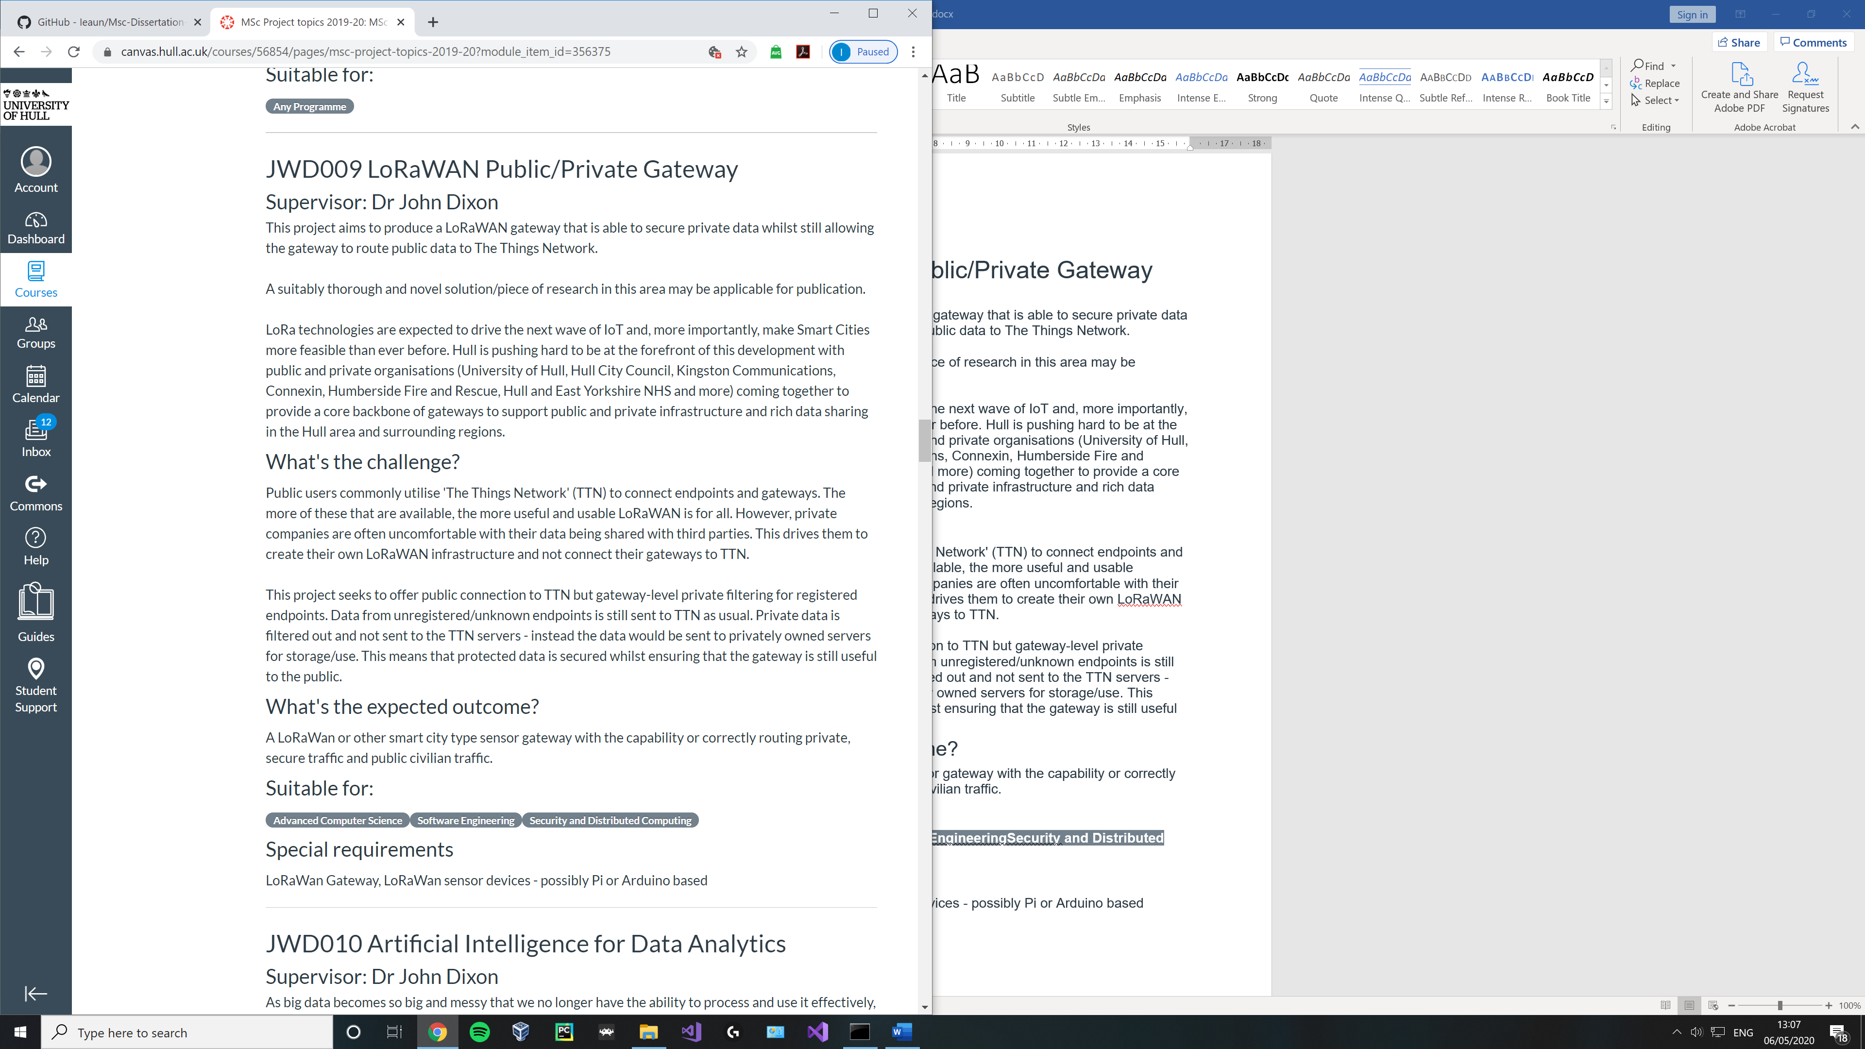

## Appendix 1.2:

##### Gateways in central London, UK

##### What gateways are they using ?

**Figure above left, LoRaWan at position 7 in adjacent table with altitude of 168**

**Figure above , LoRaWan gateways in a subset of Central London, UK**

|  |  |  |
| --- | --- | --- |
| **No** | **Brand / Model** | **Altitude (m)** |
| 1 | Laird, Sentrius RG186 (x2) | 30 |
|  | Dragino, LG305 | 30 |
|  | Dragino, LPS8 | 30 |
| 2 | Kerlink, not specified | 26 |
|  | Multitech, not specified | 6 |
| Laird, Sentrius RG186 | 6 |
| 3 | MultiTech, not specified | 54 |
|  | Kerlink, not specified | 61 |
| 4 | Tektelic, KONA Micro | - |
|  | Kerlink, station | 68 |
| 5 | Raspberry Pi based, 831 | 3 |
|  | The Things Indoor Gateway | - |
| Kerlink, not specified | 76 |
| 6 | Kerlink, not specified | 54 |
|  | Kerlink, station | - |
| Kerlink, not specified | 62 |
| 7 | Raspberry Pi based, PiSupply | 15 |
|  | Raspberry Pi based | 168 |
| The Things Indoor Gateway | 35 |
| 8 | Kerlink, not specified | 69 |
|  | Raspberry Pi based, 7243 | 60 |
| 9 | Laird, Sentrius RG186 | 19 |
|  | The Things Indoor Gateway | 20 |
|  | The Things Gateway | 18 |
| 10 | Kerlink, not specified | 20 |
|  | | |
|  | Kerlink | 43 |

##### Gateways in Manchester, UK

##### What gateways are they using ?

|  |  |  |
| --- | --- | --- |
| **No** | **Brand / Model** | **Altitude (m)** |
| 1 | Kerlink, Station | 27 |
| 2 | - | 20 |
| 3 | TTN-001-868-1.0 | - |
|  | Kerlink, Station | - |
| 4 | The Things Gateway | 26 |
|  | Kerlink, Station | - |
|  | Kerlink, Station | - |
| 5 | Kerlink, Station | - |
|  | Laird, Sentrius RG186 | 48 |
|  | The Things Indoor Gateway | 74 |
| 6 | - | 80 |
| 7 | Laird, not specified | - |
|  | Laird, Sentrius RG186 | - |
|  | | |
|  | Kerlink, Station | 46 |

**Figure above , LoRaWan gateways in a subset of Manchester, UK**

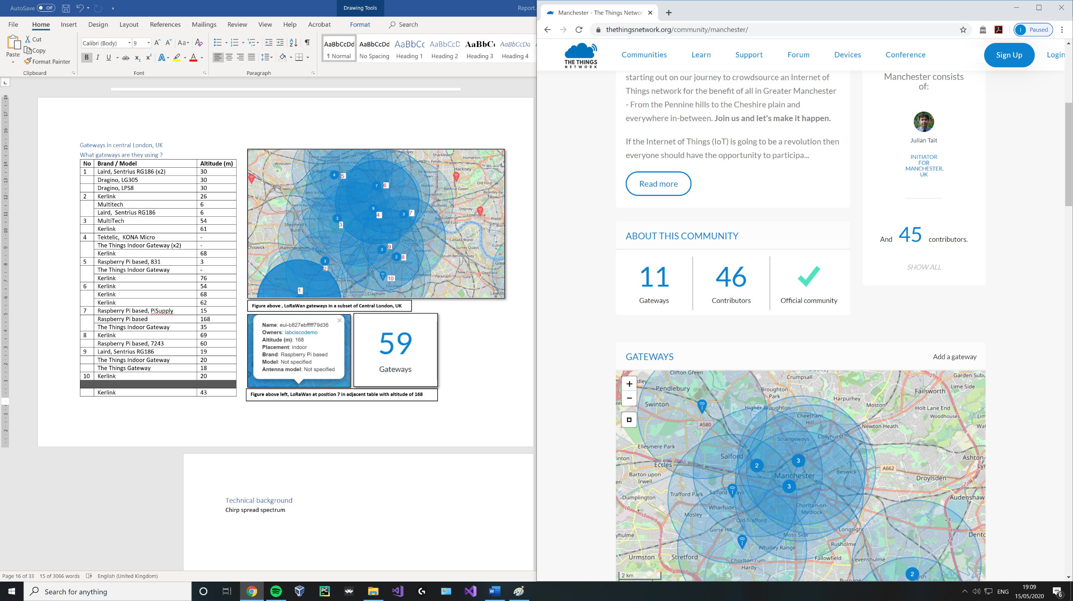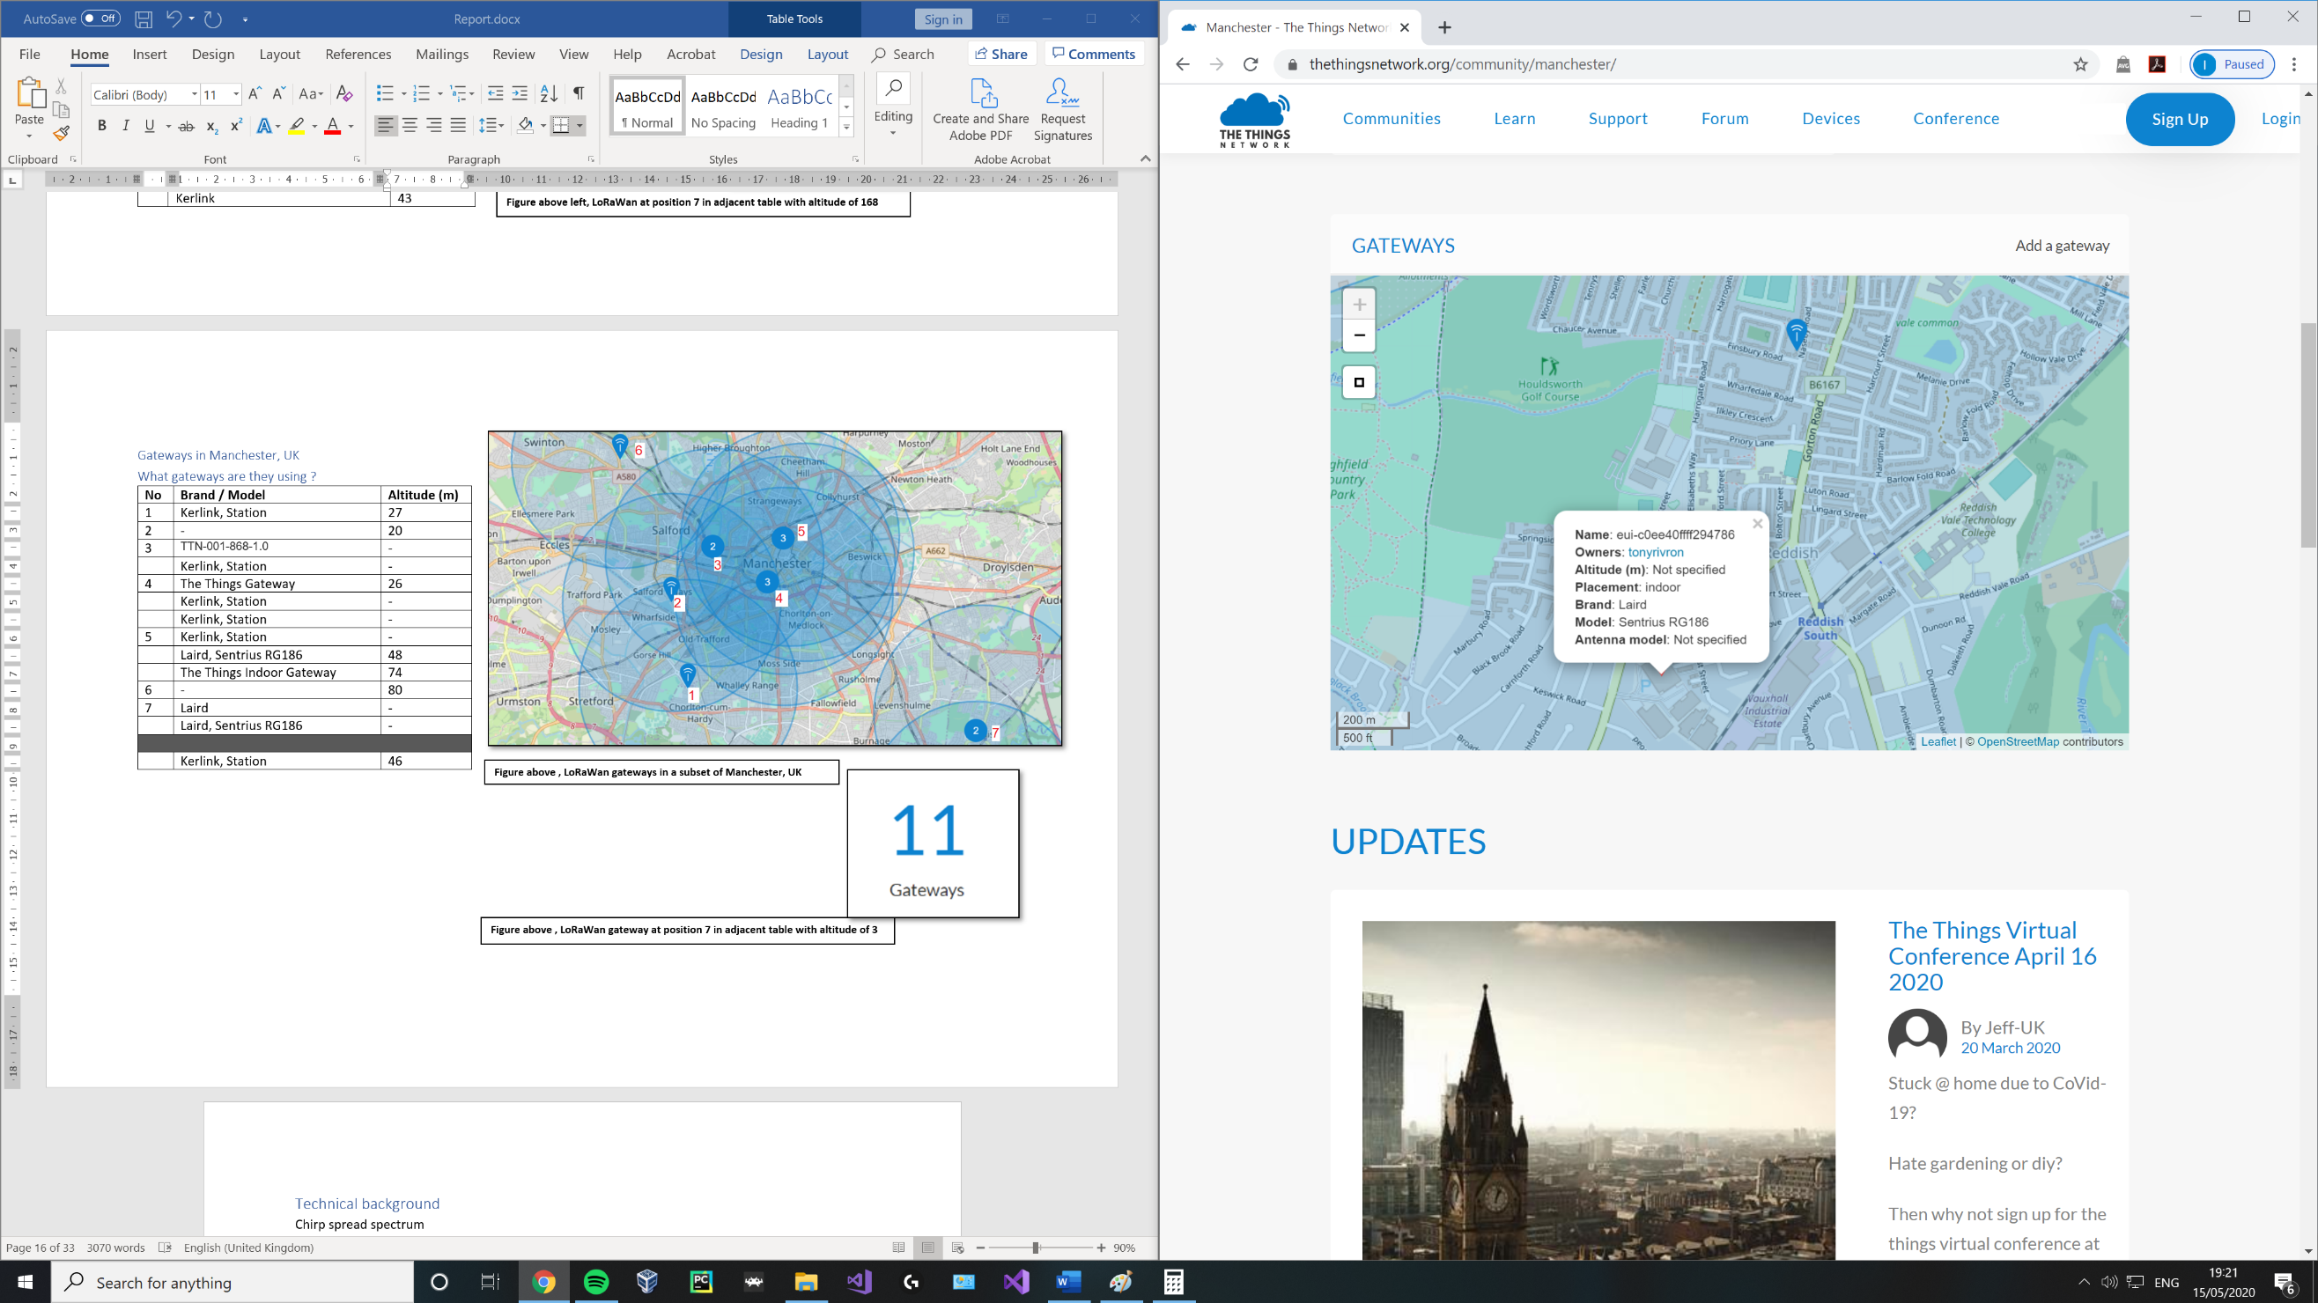

**Figure above , LoRaWan gateway at position 7 in adjacent table using a Laird Sentruis**

##### Gateways in Liverpool, UK

##### What gateways are they using ?

**Figure above , LoRaWan gateways in a subset of Liverpool, UK**

|  |  |  |
| --- | --- | --- |
| **No** | **Brand / Model** | **Altitude (m)** |
| 1 | Raspberry Pi based | 22 |
|  | - | 107 |
|  | Raspberry Pi based | - |
|  | IOTLTD v. 10 | 42 |
|  | IOTLTD v. 10 | 93 |
|  | IOTLTD v. 10 | 87 |
|  | The Things Indoor Gateway | 20 |
| 2 | IOTLTD | - |
|  | Raspberry Pi based | - |
|  | Raspberry Pi with IMST iC880A | 3 |
|  | IOTLTD v. 10 | 28 |
|  | Gemtek, TTIOG | 30 |
|  | Laird Sentrius RG186 | 60 |
|  | The Things Indoor Gateway | - |
|  | The Things Gateway | 46 |
|  | IOTLTD v. 10 | 176 |
|  | - | 82 |
|  | Raspberry Pi based | 5 |
| 3 | Raspberry Pi based | 70 |
|  | Raspberry Pi based, IMST | - |
|  | Raspberry Pi based | - |
|  | Raspberry Pi based | - |
|  | | |
|  | IOTLTD v. 10 | 58 |

**Figure above , LoRaWan gateway at position 2 in adjacent table using a Laird Sentruis**

##### Gateways in Birmingham, UK

##### What gateways are they using ?

|  |  |  |
| --- | --- | --- |
| **No** | **Brand / Model** | **Altitude (m)** |
| 1 | MultiTech, Conduit | 20 |
| 2 | The Things Indoor Gateway | - |
| 3 | The Things Indoor Gateway | - |
|  | The Things Indoor Gateway | - |
|  | | |
|  | The Things Indoor Gateway | 20 |

**Figure above , LoRaWan gateways in a subset of Birmingham, UK**

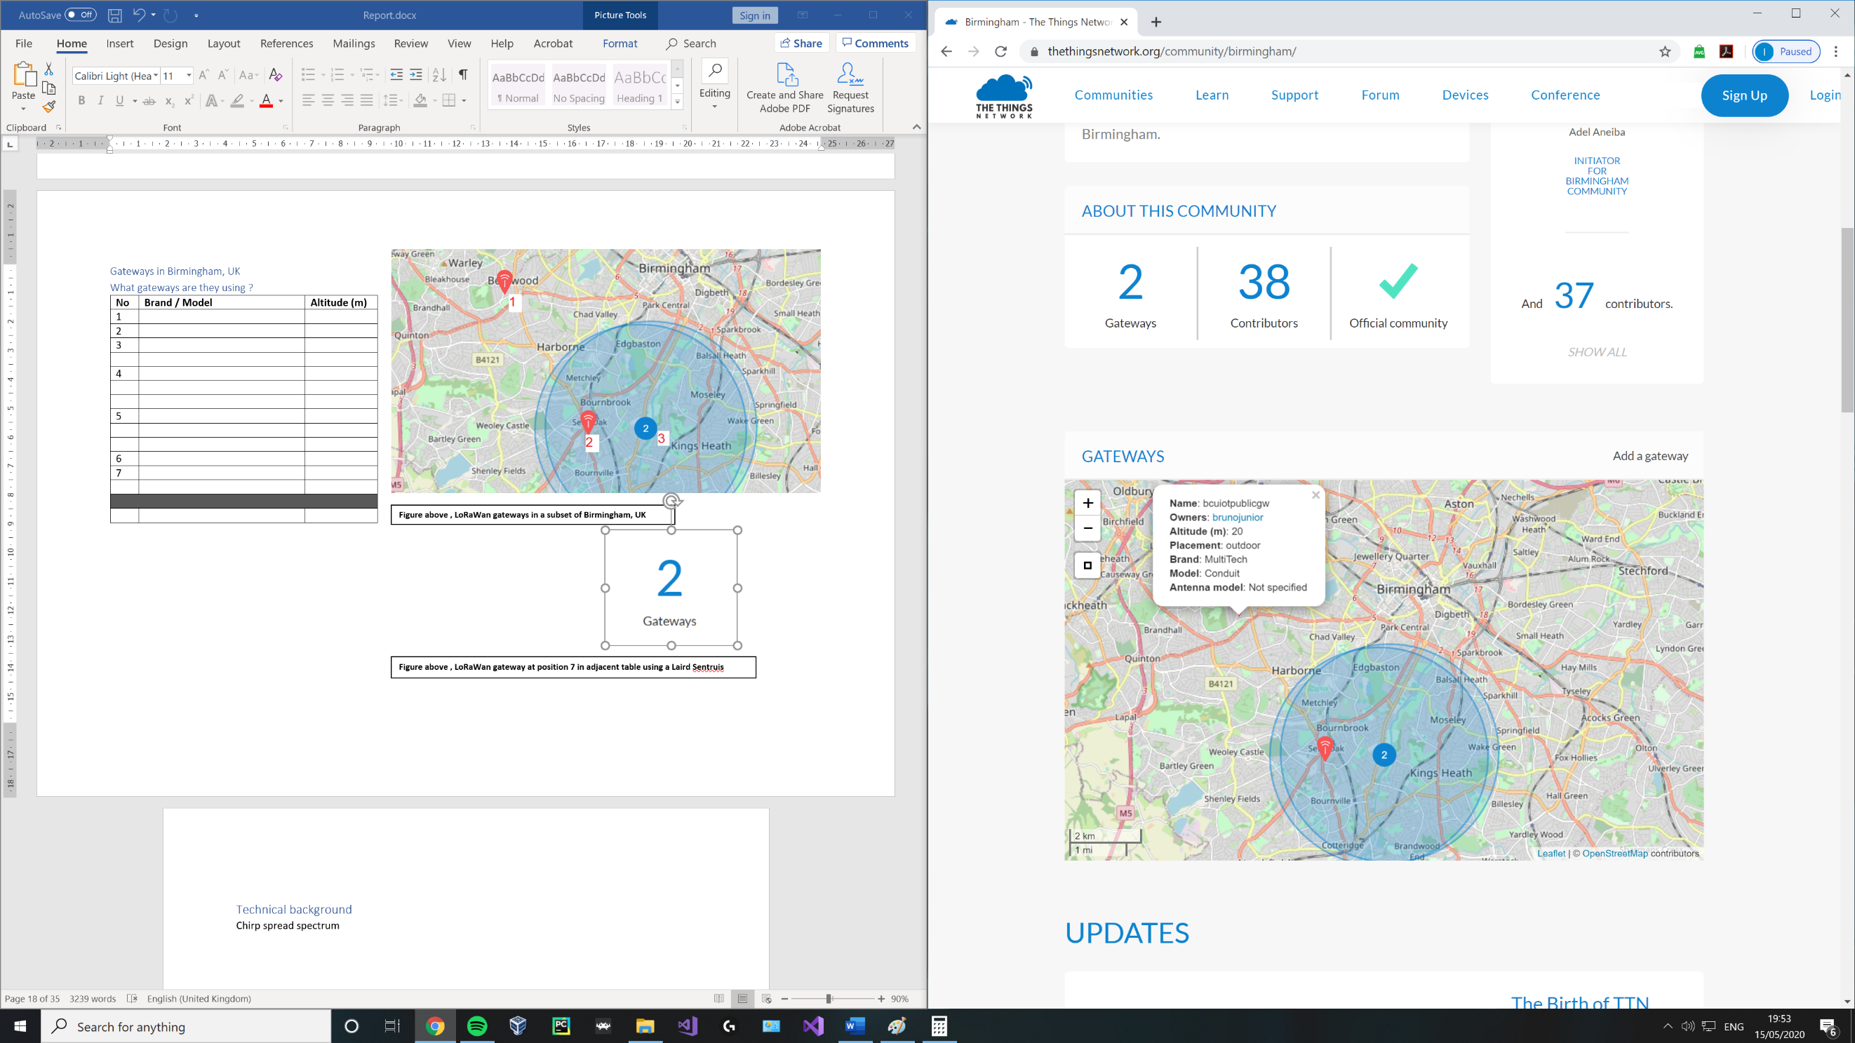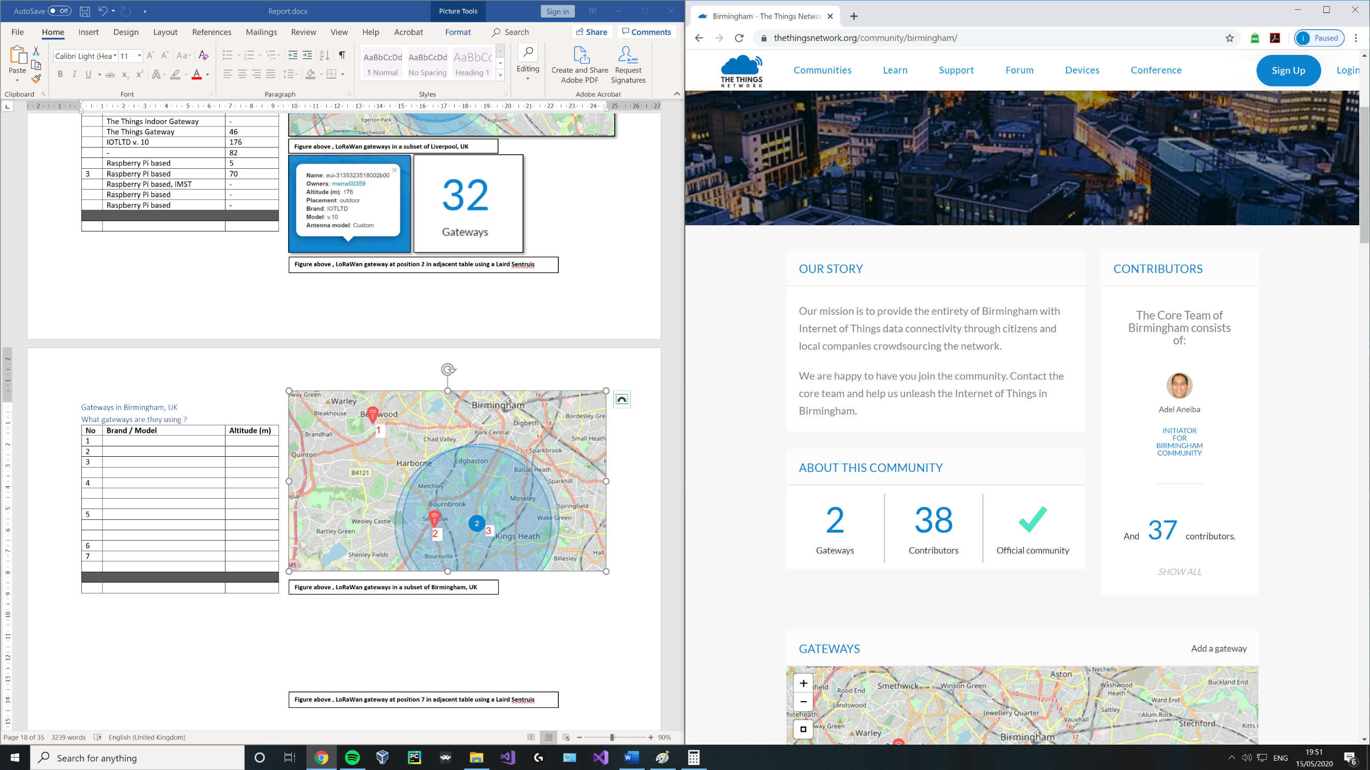

**Figure above , LoRaWan gateway at position 1 in adjacent table using a MultiTech, Conduit**

##### Gateways in Leeds and Bradford, UK

##### What gateways are they using ?

|  |  |  |
| --- | --- | --- |
| **No** | **Brand / Model** | **Altitude (m)** |
| 1 | Raspberry Pi based, RAK831 | - |
| 2 | Kerlink, Station | 173 |
| 3 | Kerlink, Station | 154 |
| 4 | Kerlink, Femtocell | 4 |
|  | MultiTech, Conduit | 50 |
|  | The Things Indoor Gateway | - |
| 5 | Beagle Bone Black with RAK831 | 120 |
|  | Cisco, IXM | - |
|  | MultiTech, Conduit | 50 |
|  | | |
|  | Kerlink, Station /  MultiTech, Conduit | 92 |

**Figure above , LoRaWan gateways in Leeds and Bradford, UK**

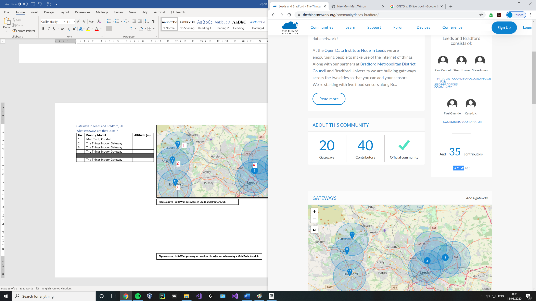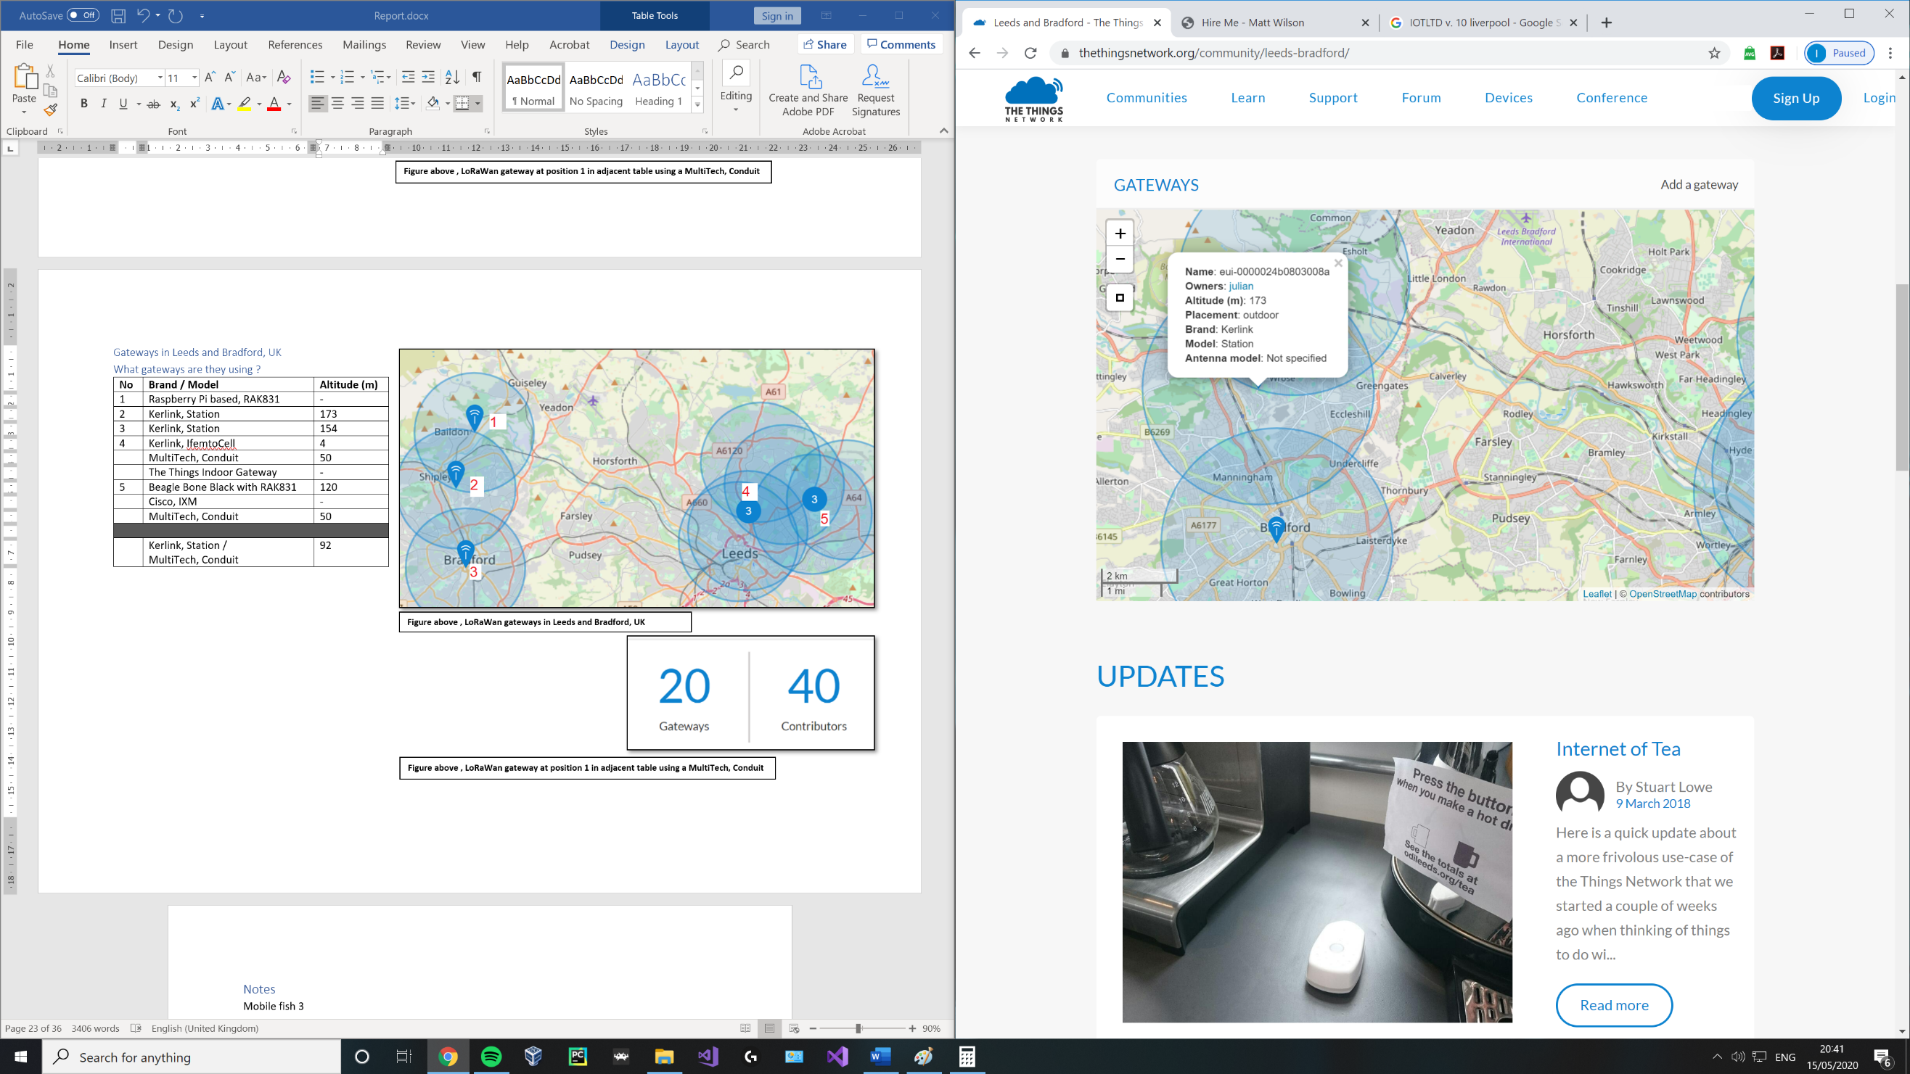

**Figure above , LoRaWan gateway at position 1 in adjacent table using a MultiTech, Conduit**

## Notes

Mobile fish 3

Time on air – time it takes a senders packet to reach a receiver.

Duty cycle – proportion of time during which a component, device or system is operated, can be expressed as a ratio or percentage.

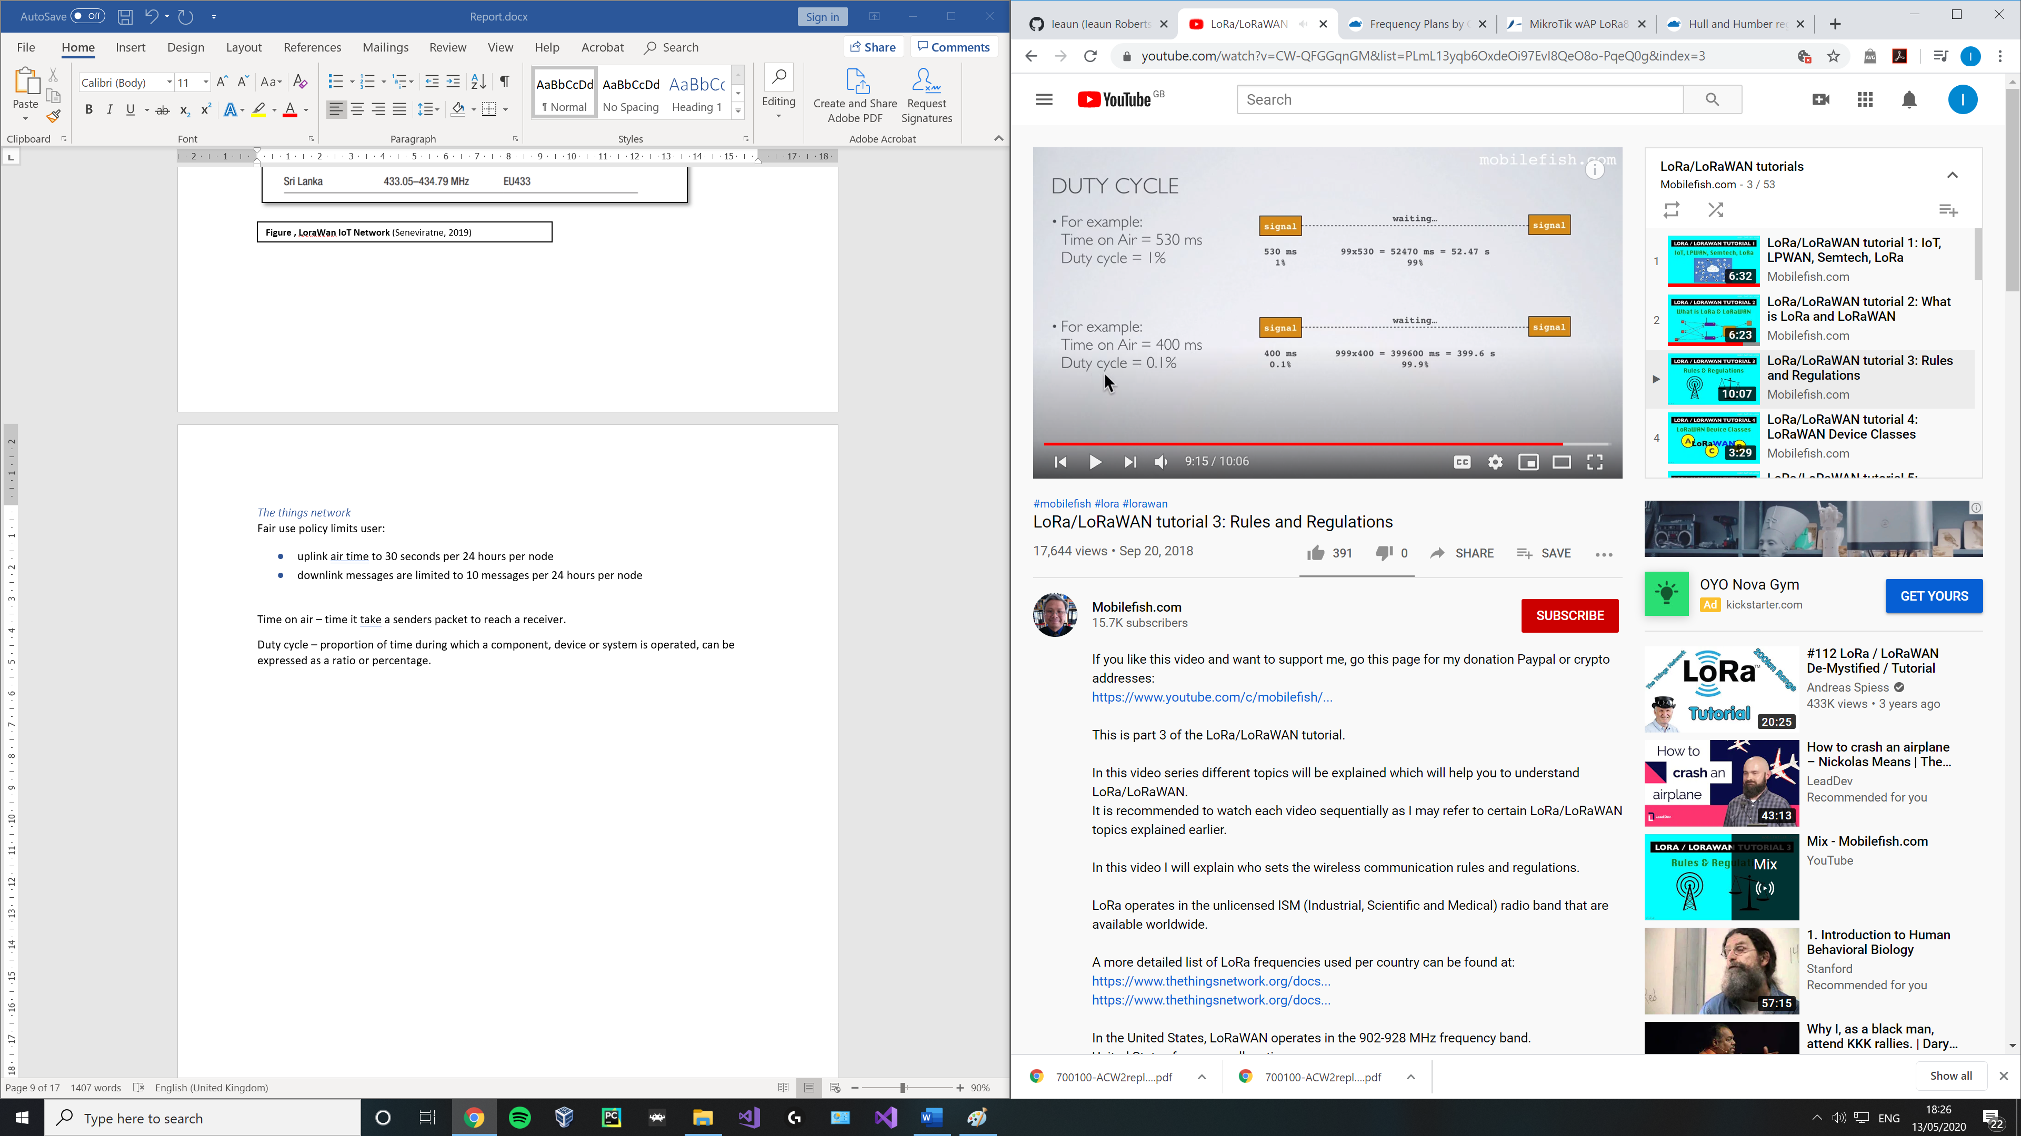

This needs to be in place otherwise anyone can broadcast an unlimited amount rendering the band useless.

Mobile fish 4

LoRaWan spec defines 3 device classes

1. All – battery powers, each device uplink to the gateway and is followed by two short downlink reciece windows
2. Beacon- same as class a but open extra receive windows
3. Continuous - same as a but continuously lison, use far more power and are often mains power

1 at any time an endnode can broadcast a signal, after this transmission the end node will listen for a response from the gateway.The end node opens 2 reciving slots, one at time T1 and another at time T2. The gateway can respond within the first or second slot but not both.

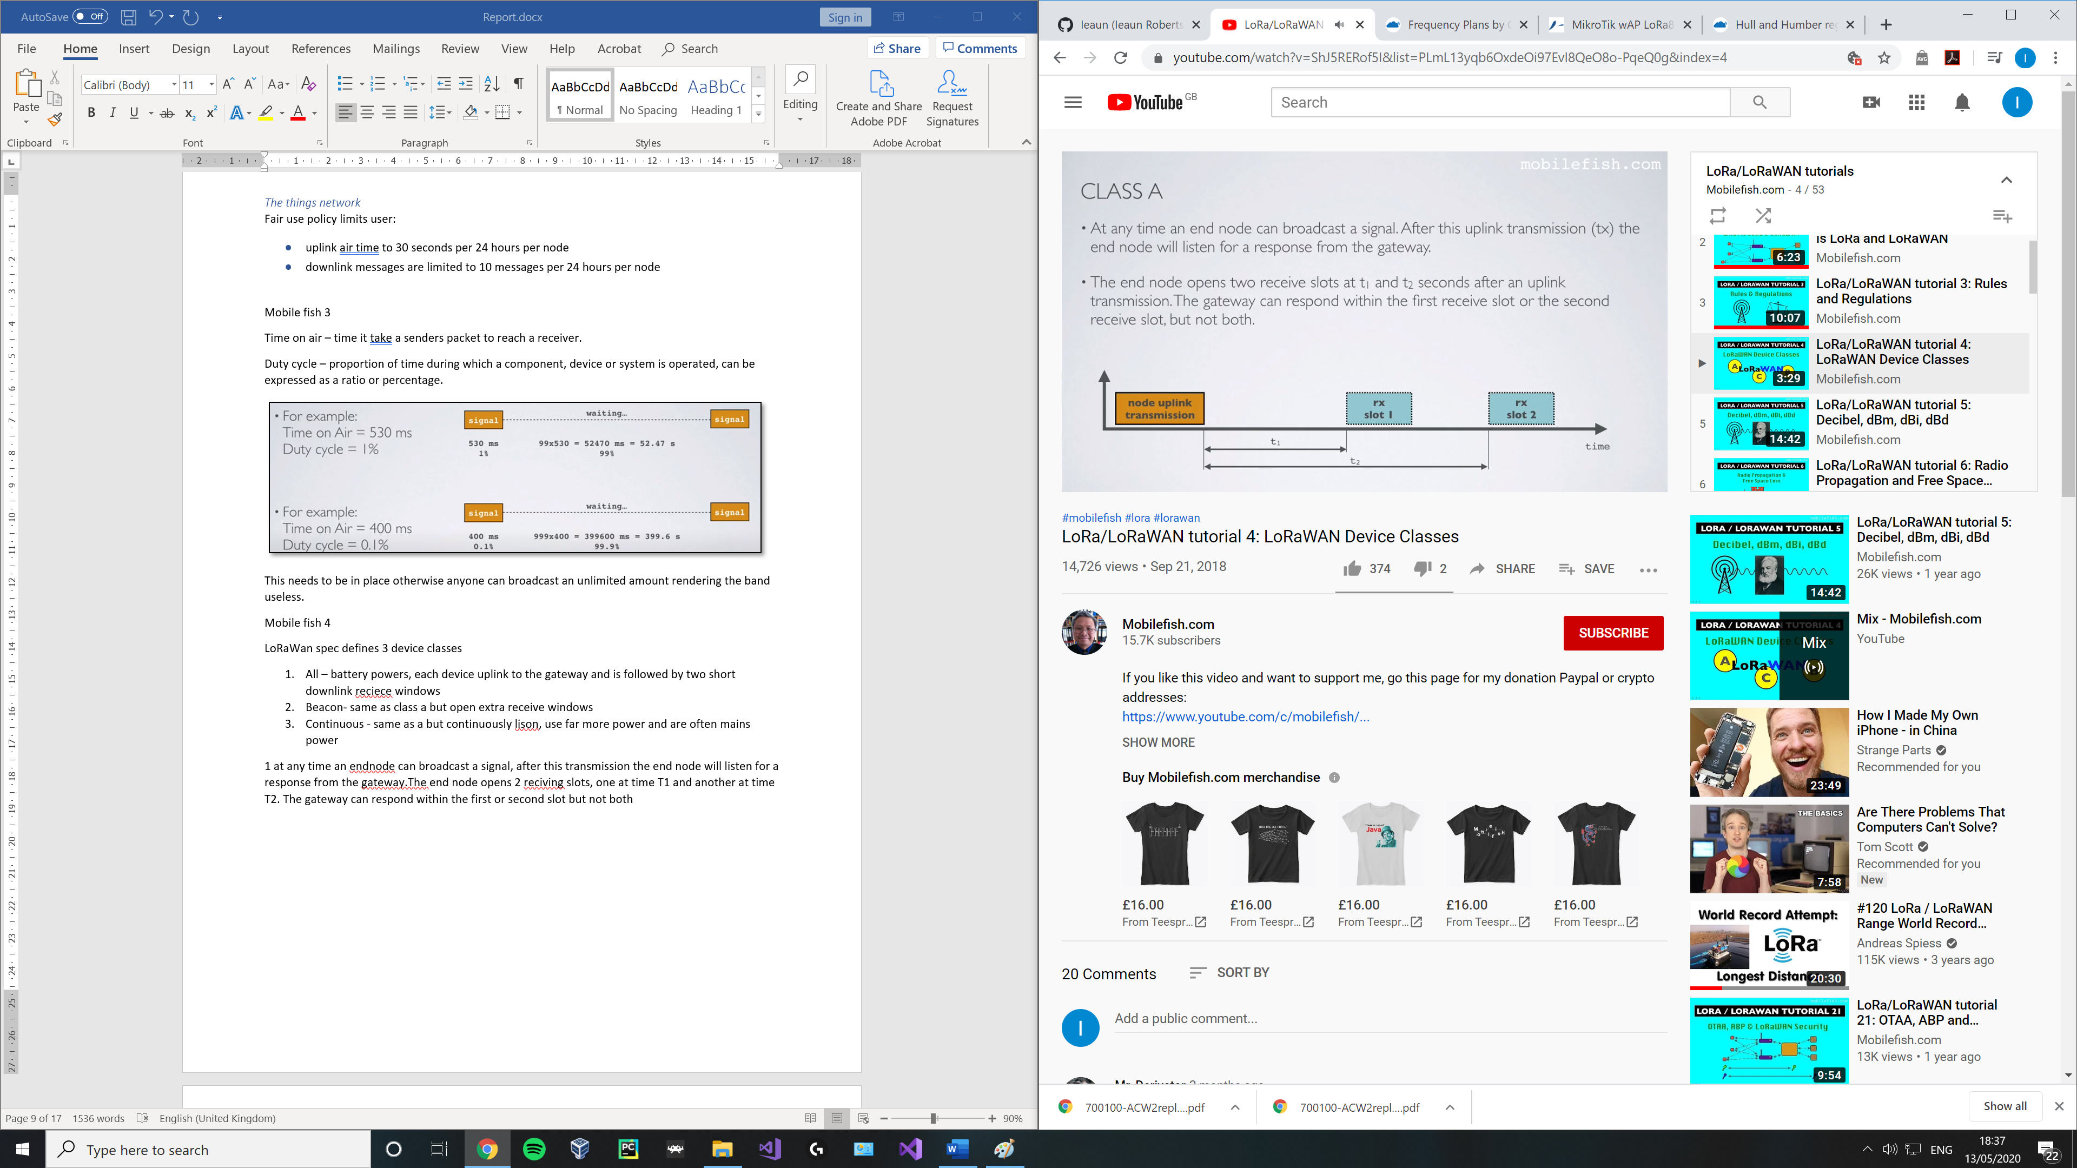

2 class b devices do class a but open extra receive slots at scheduled time, the end node receives a time sycronized beacon from the gateway allowinf the gateway to know when the node is listening. Class B does not support class C funcitonmlity

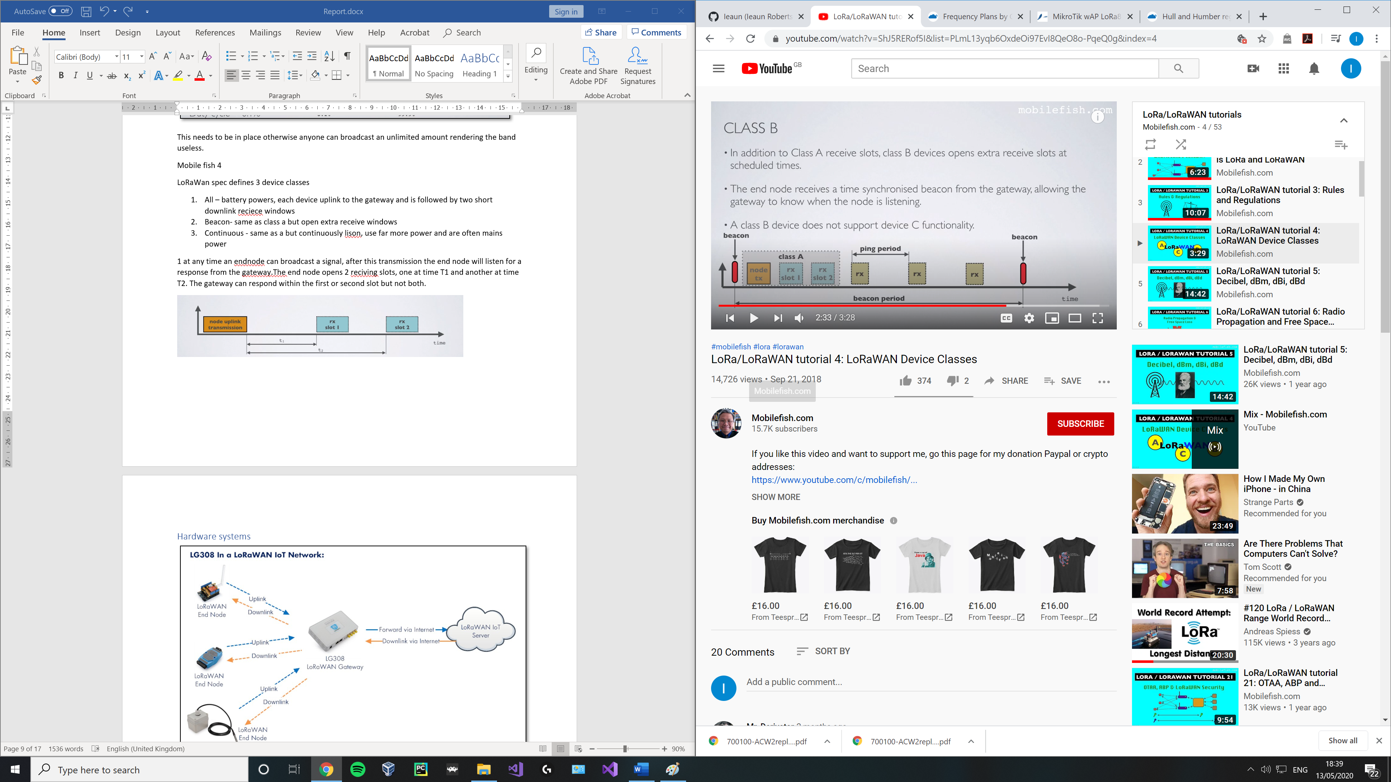

3 class c does a and then also listens continuously for responses from the gateway. Class c does not support class b functionality

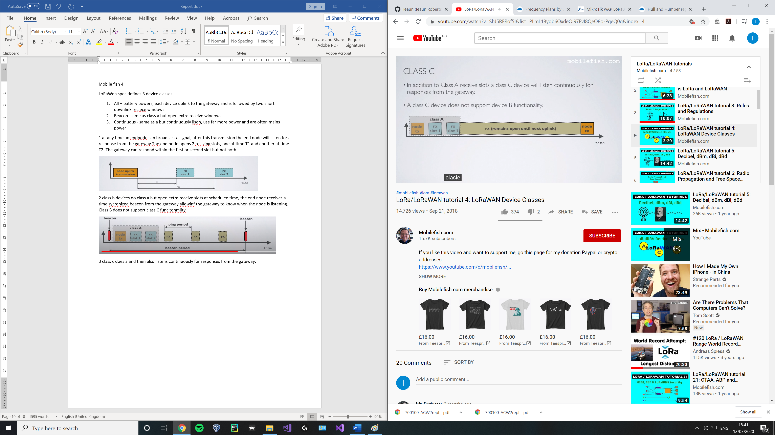

Mobile fish 5

Decibel: unit of measure used to express the ratio of power, sound, pressure. Not absolute value, only ratio.

-used to express the ratio of electrical powers

Amplifier – 2 w -> 6w, 4.7 db gain

Cable – 10w-> 8w, -0.98 db loss

Mobile fish 6

Propagation is the way rado waves ravel through a medium. The way they travel affects signal strength.

Line of site propogation – radio waves travel directly from sender to receiver without any obsticles. If distance is larger signal will be weaker. This loss is known as free space loss, it is the largest loss in a radio communication system.

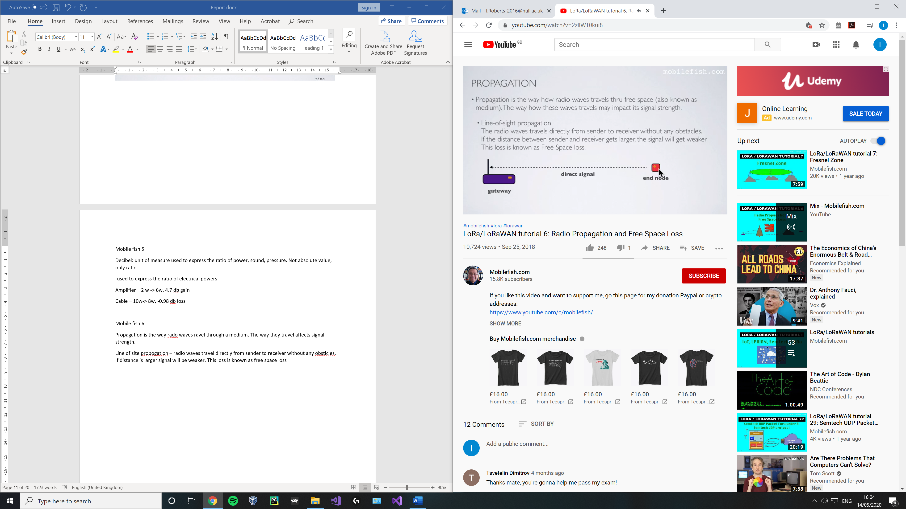

If there are obstacles near its path (within the Fresnel zone) the radio waves reflecting off those objects may arrive out of phase with the signal that travels directly and reduce the power of the received signal.

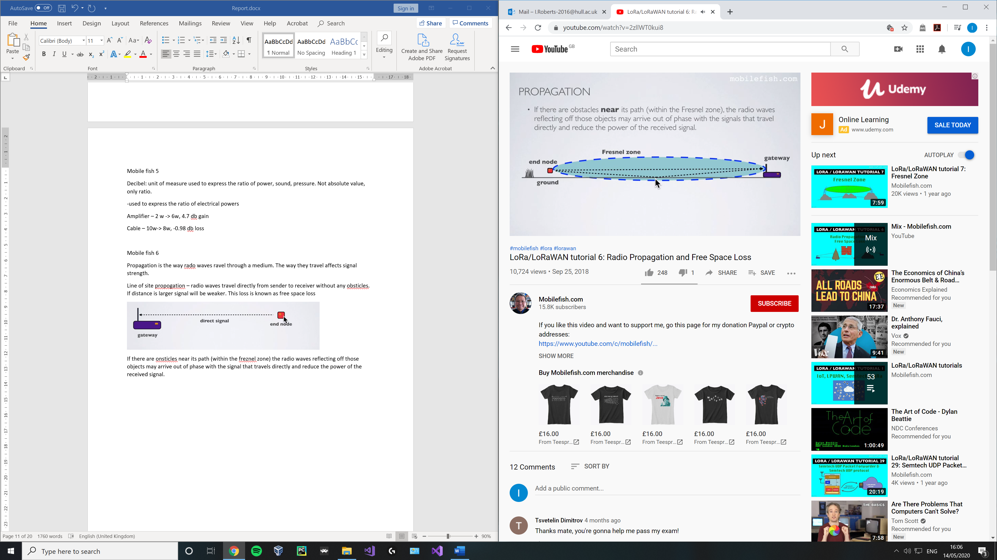

Radio waves may penetrate thorugh obstacles in its path, the waves lose strength if traveling through obsticles made of more conductive materials

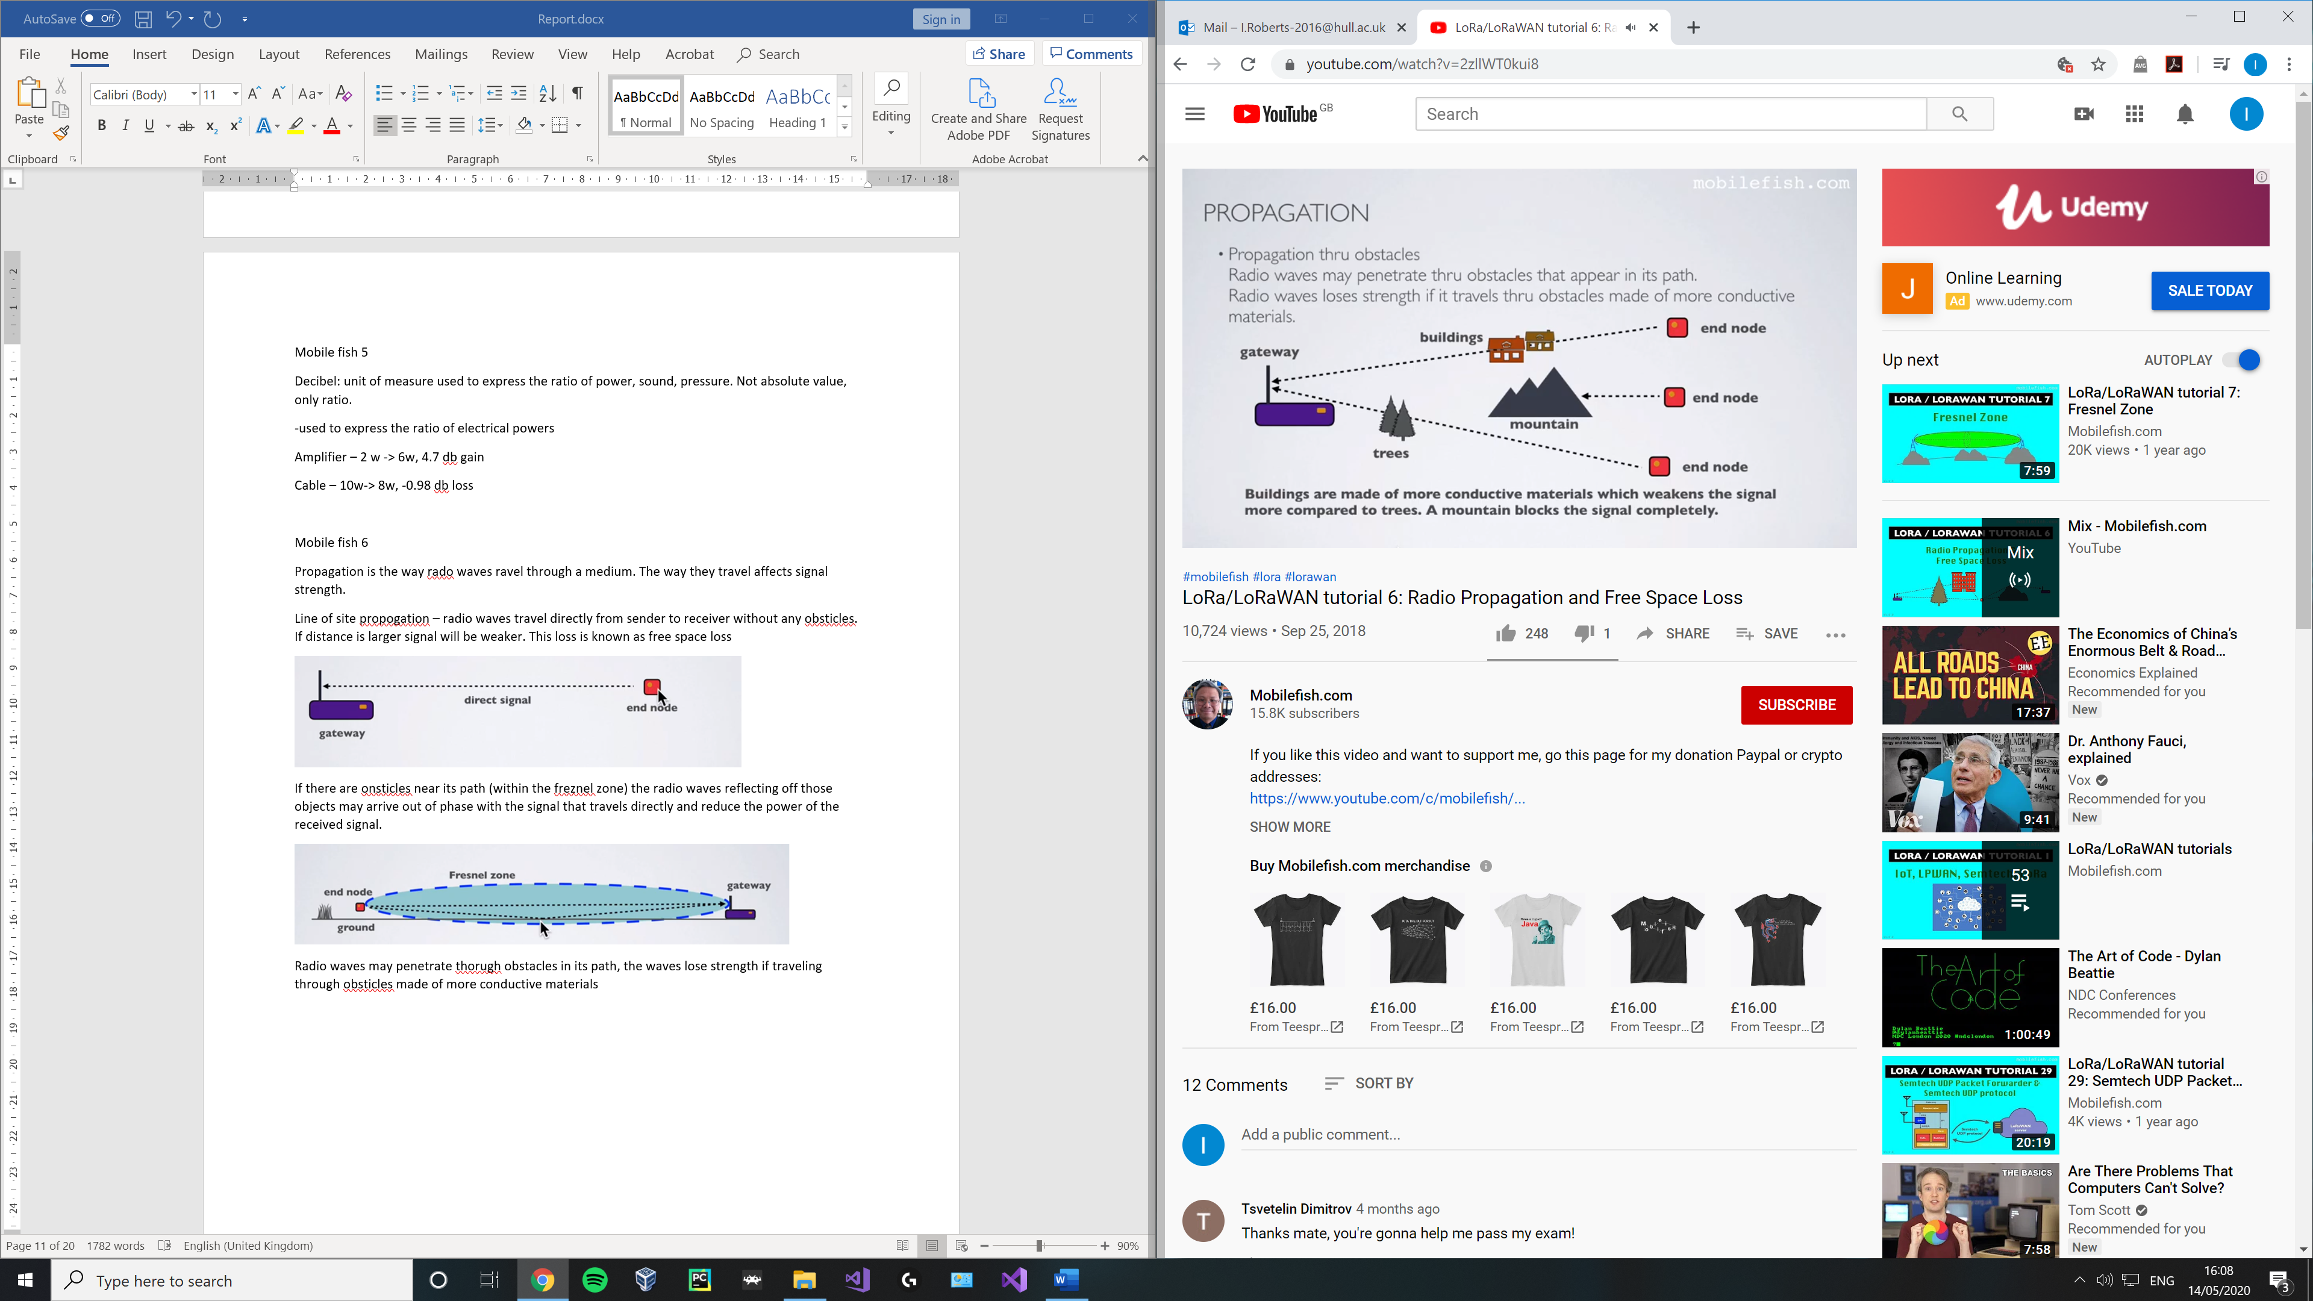

Propagations through reflecting, radio waves can be reflected by buildings which interfere with its direct signal.

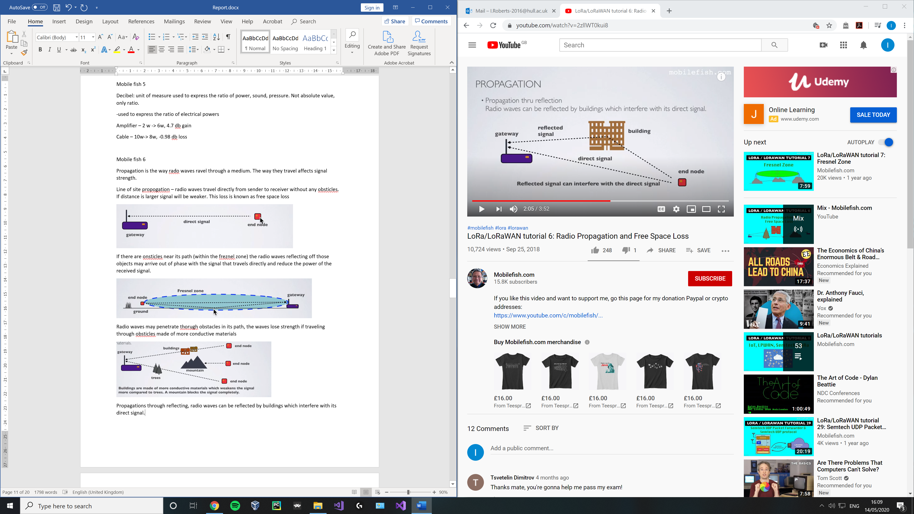

Propagation through diffraction, where radio waves are bent around sharp edges. Signals from a transmitter may be received by the gatewat even though it may be shafded by a large obstacle.

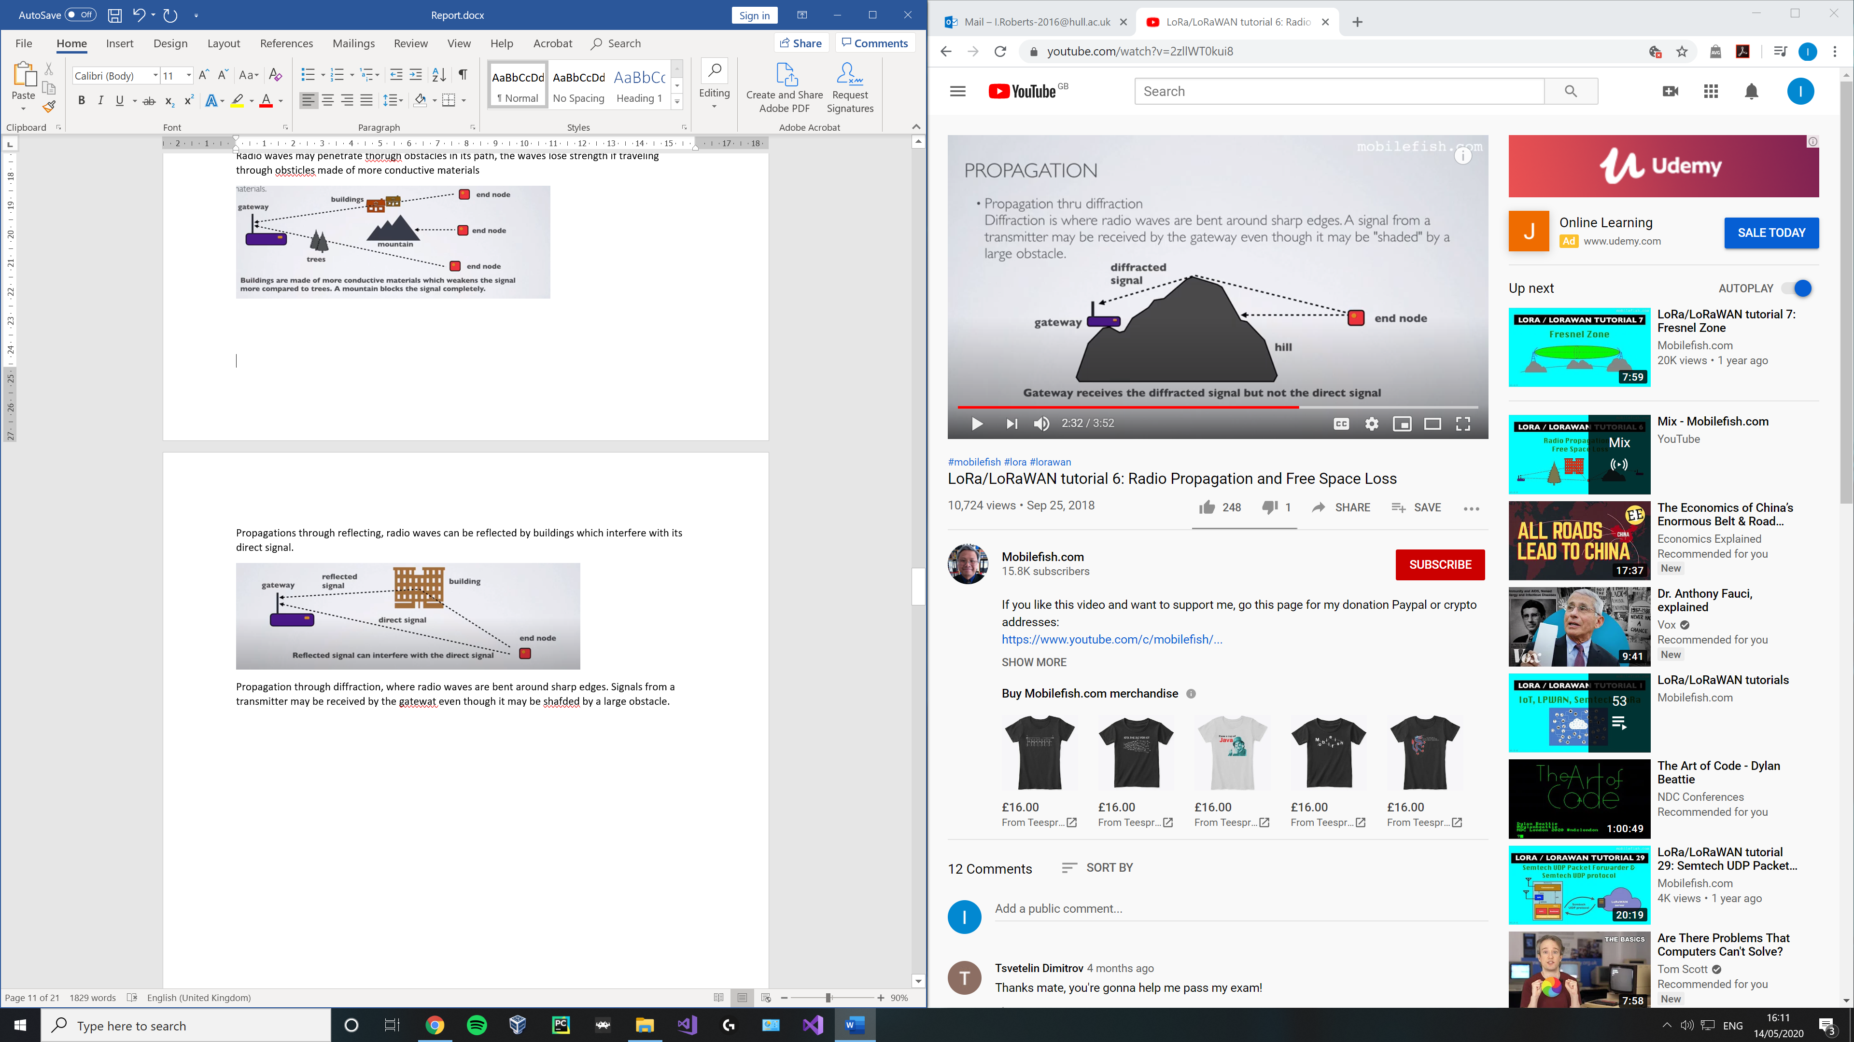

1. Line of sight propagation
2. Propagation through obstacles
3. Propagation through reflection
4. Propagation through diffraction

Mobile fish 7

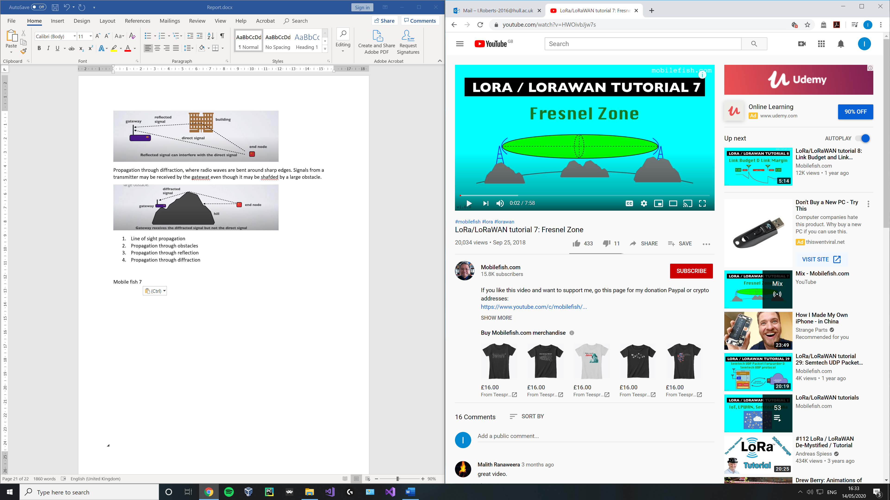

The Fresnel zone body around the direct line of sight path between the end node and the gateway. Any obstacle within this volume (trees, buildings, hiltops) weakens the signal even if there is a direct line of sight between node and gateway.

The maximum radius o the Fresnel zone is located half the distance between the end node and gateway and is calculate as follows:

R = 8.657 x sqrt (D/f)

R = Fresnel zone radius in m

D = distance in km

F = frequency

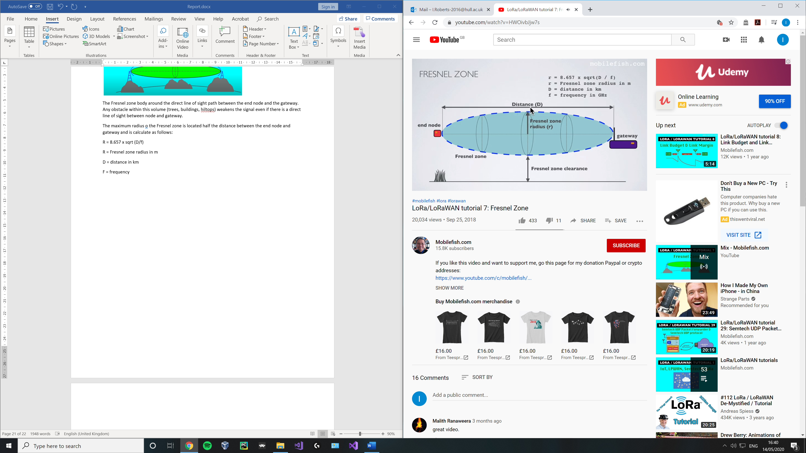

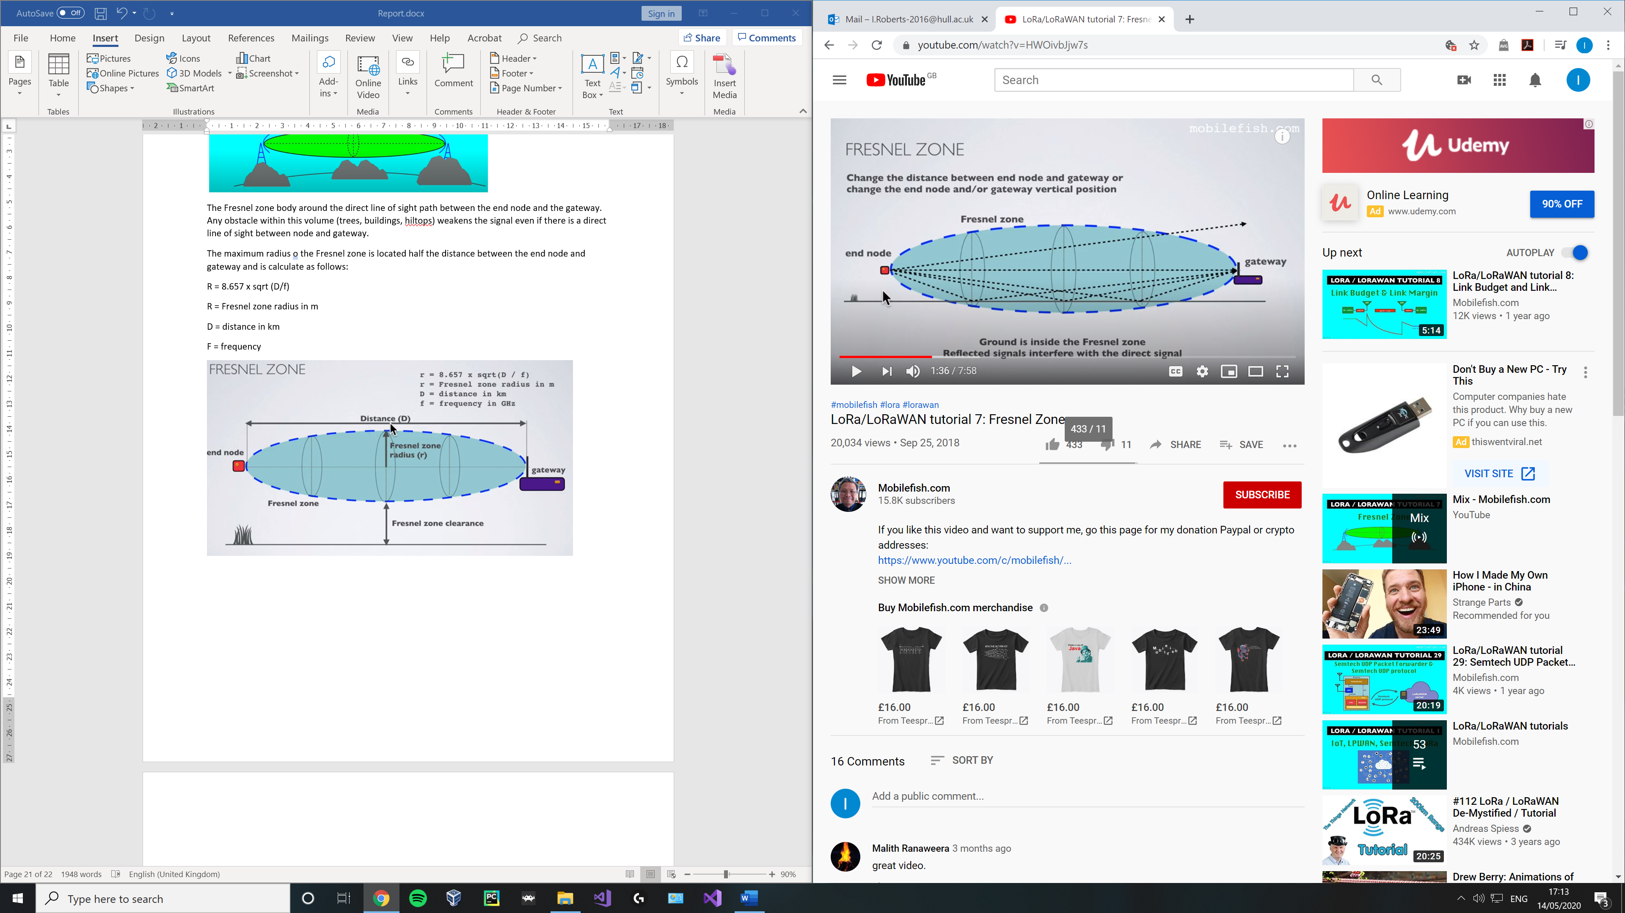

If you increase the distance then the ground enters the Fresnel zone and the signal is reflected which intefers with the direct signal.

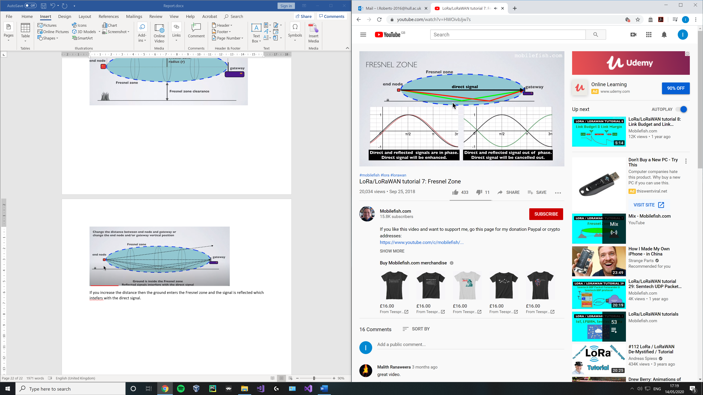

Place antenna for gateway at higher locations to avoid interference.

Fresnel equation is based on a flat earth and doesn’t take into consideration the earths curvature.

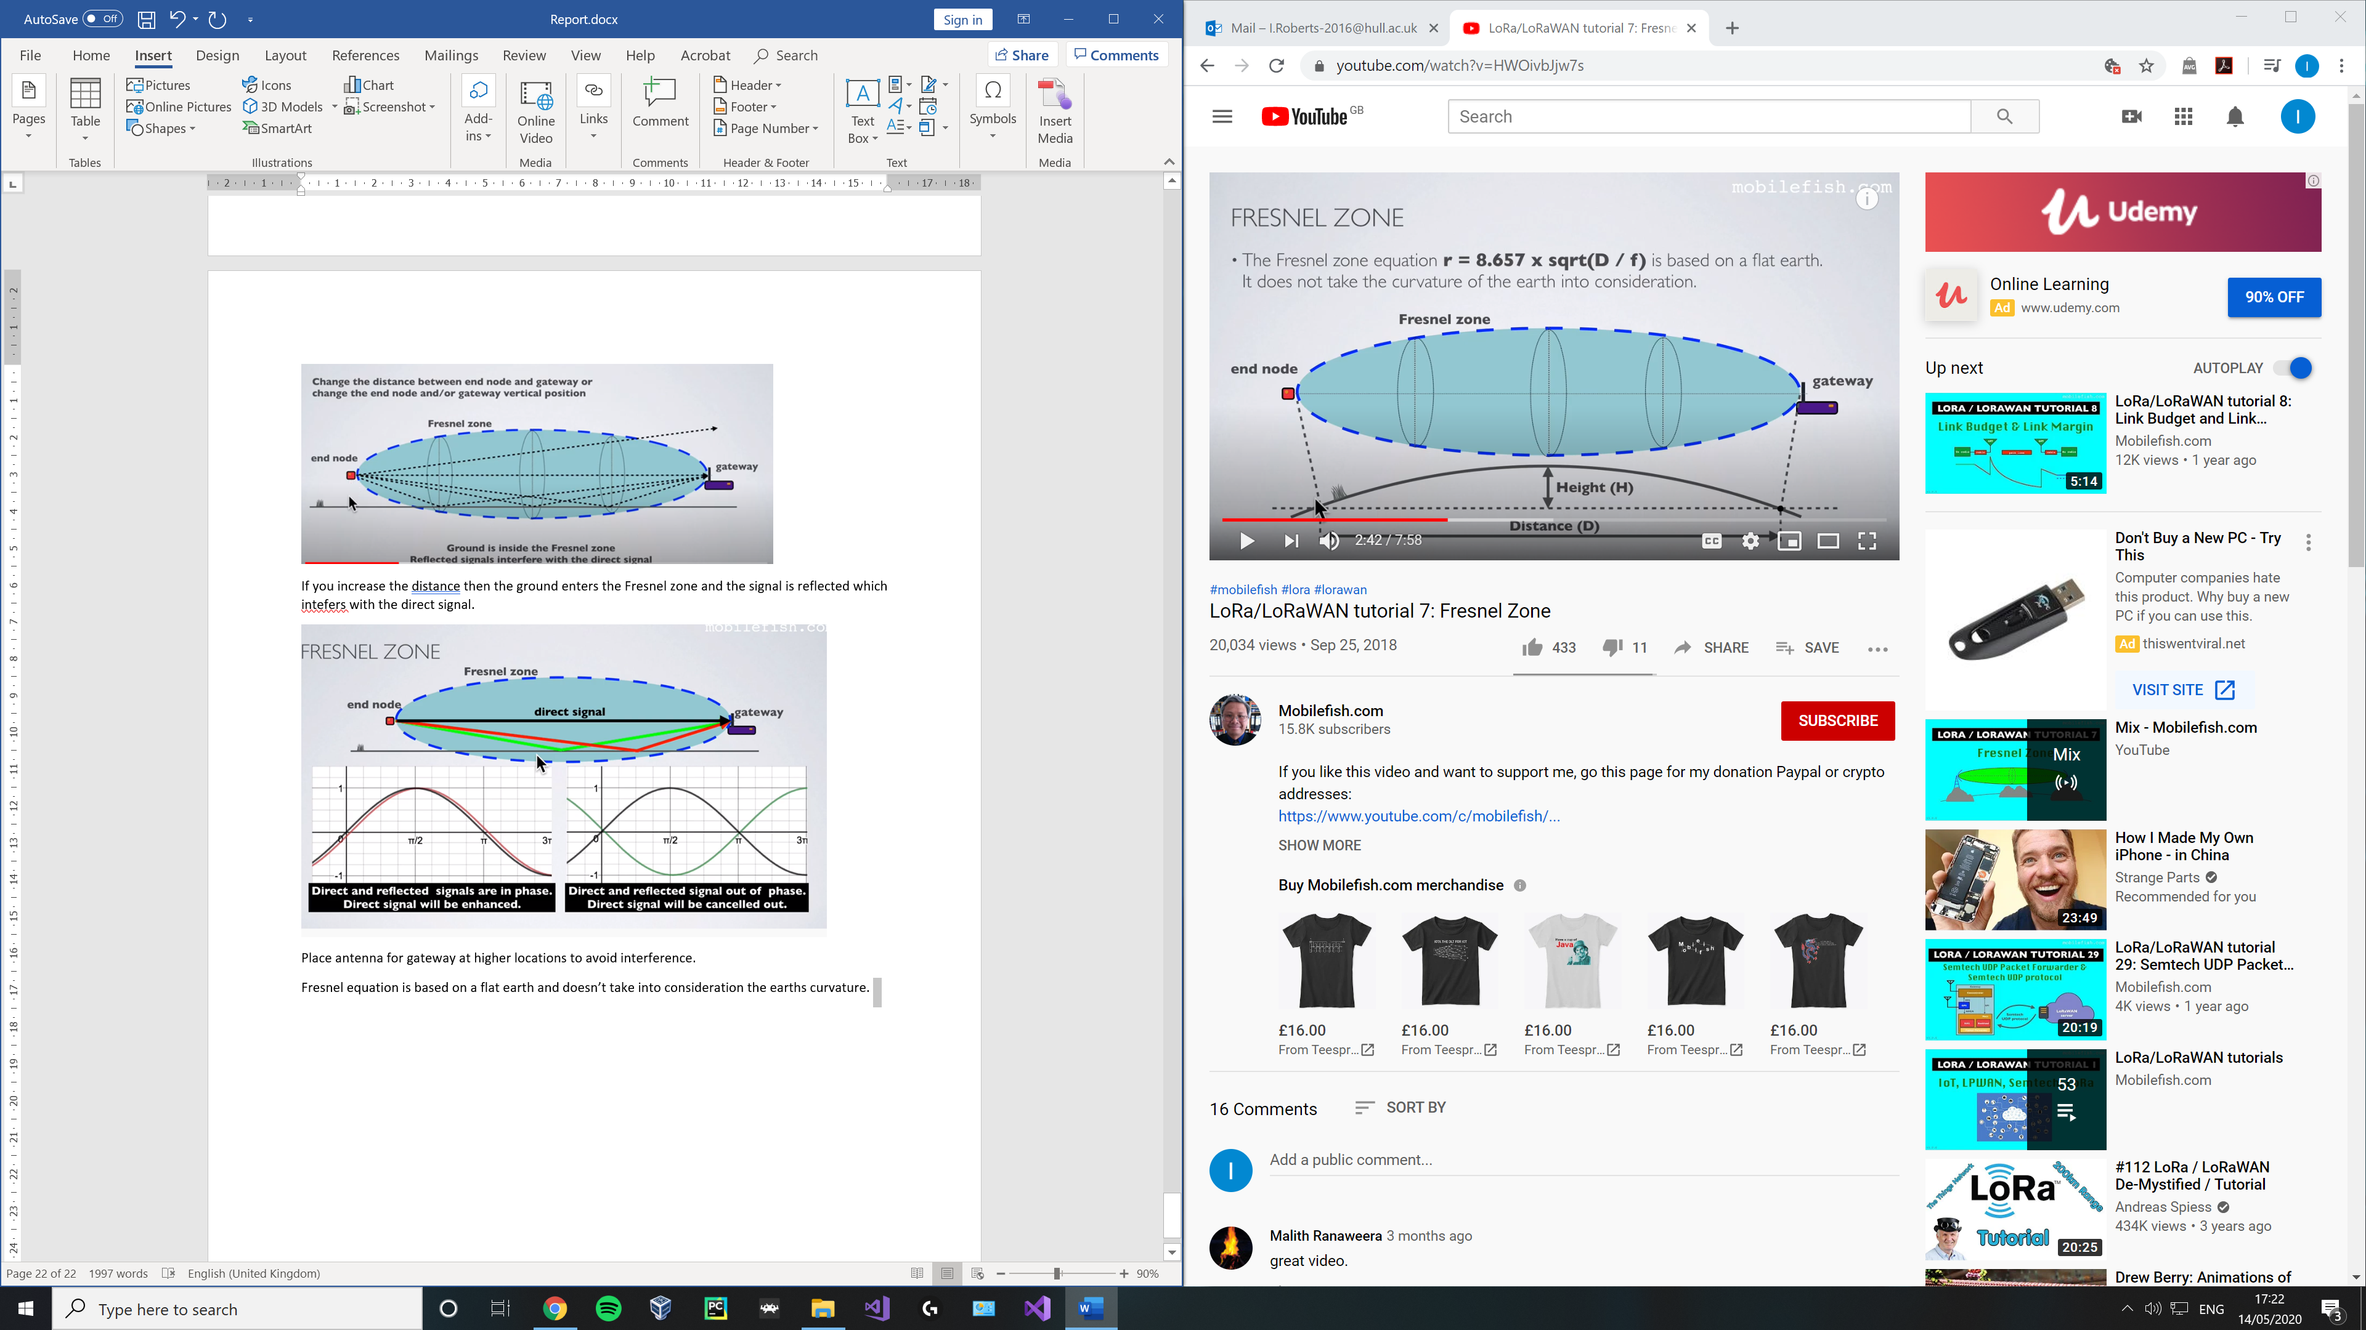

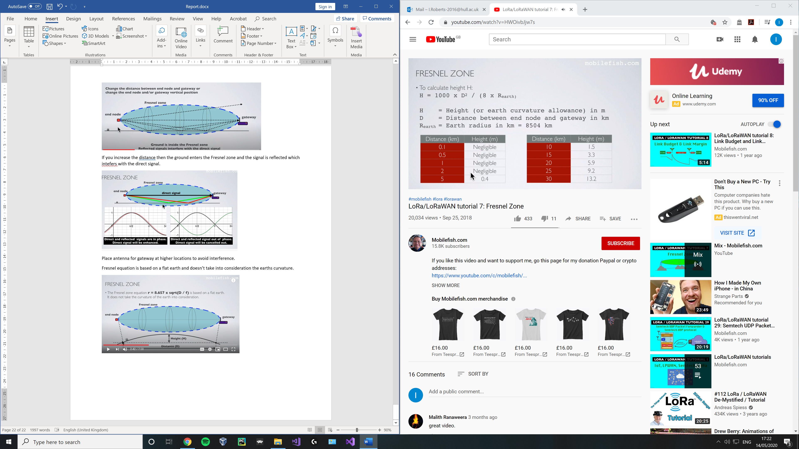

As a rule of thumb the freznel zone shoul always be atleast 60% clear (no more than 40% blockage)

R = 8.657 x sqrt((0.6 x D) / f)

F = frequency in Ghz

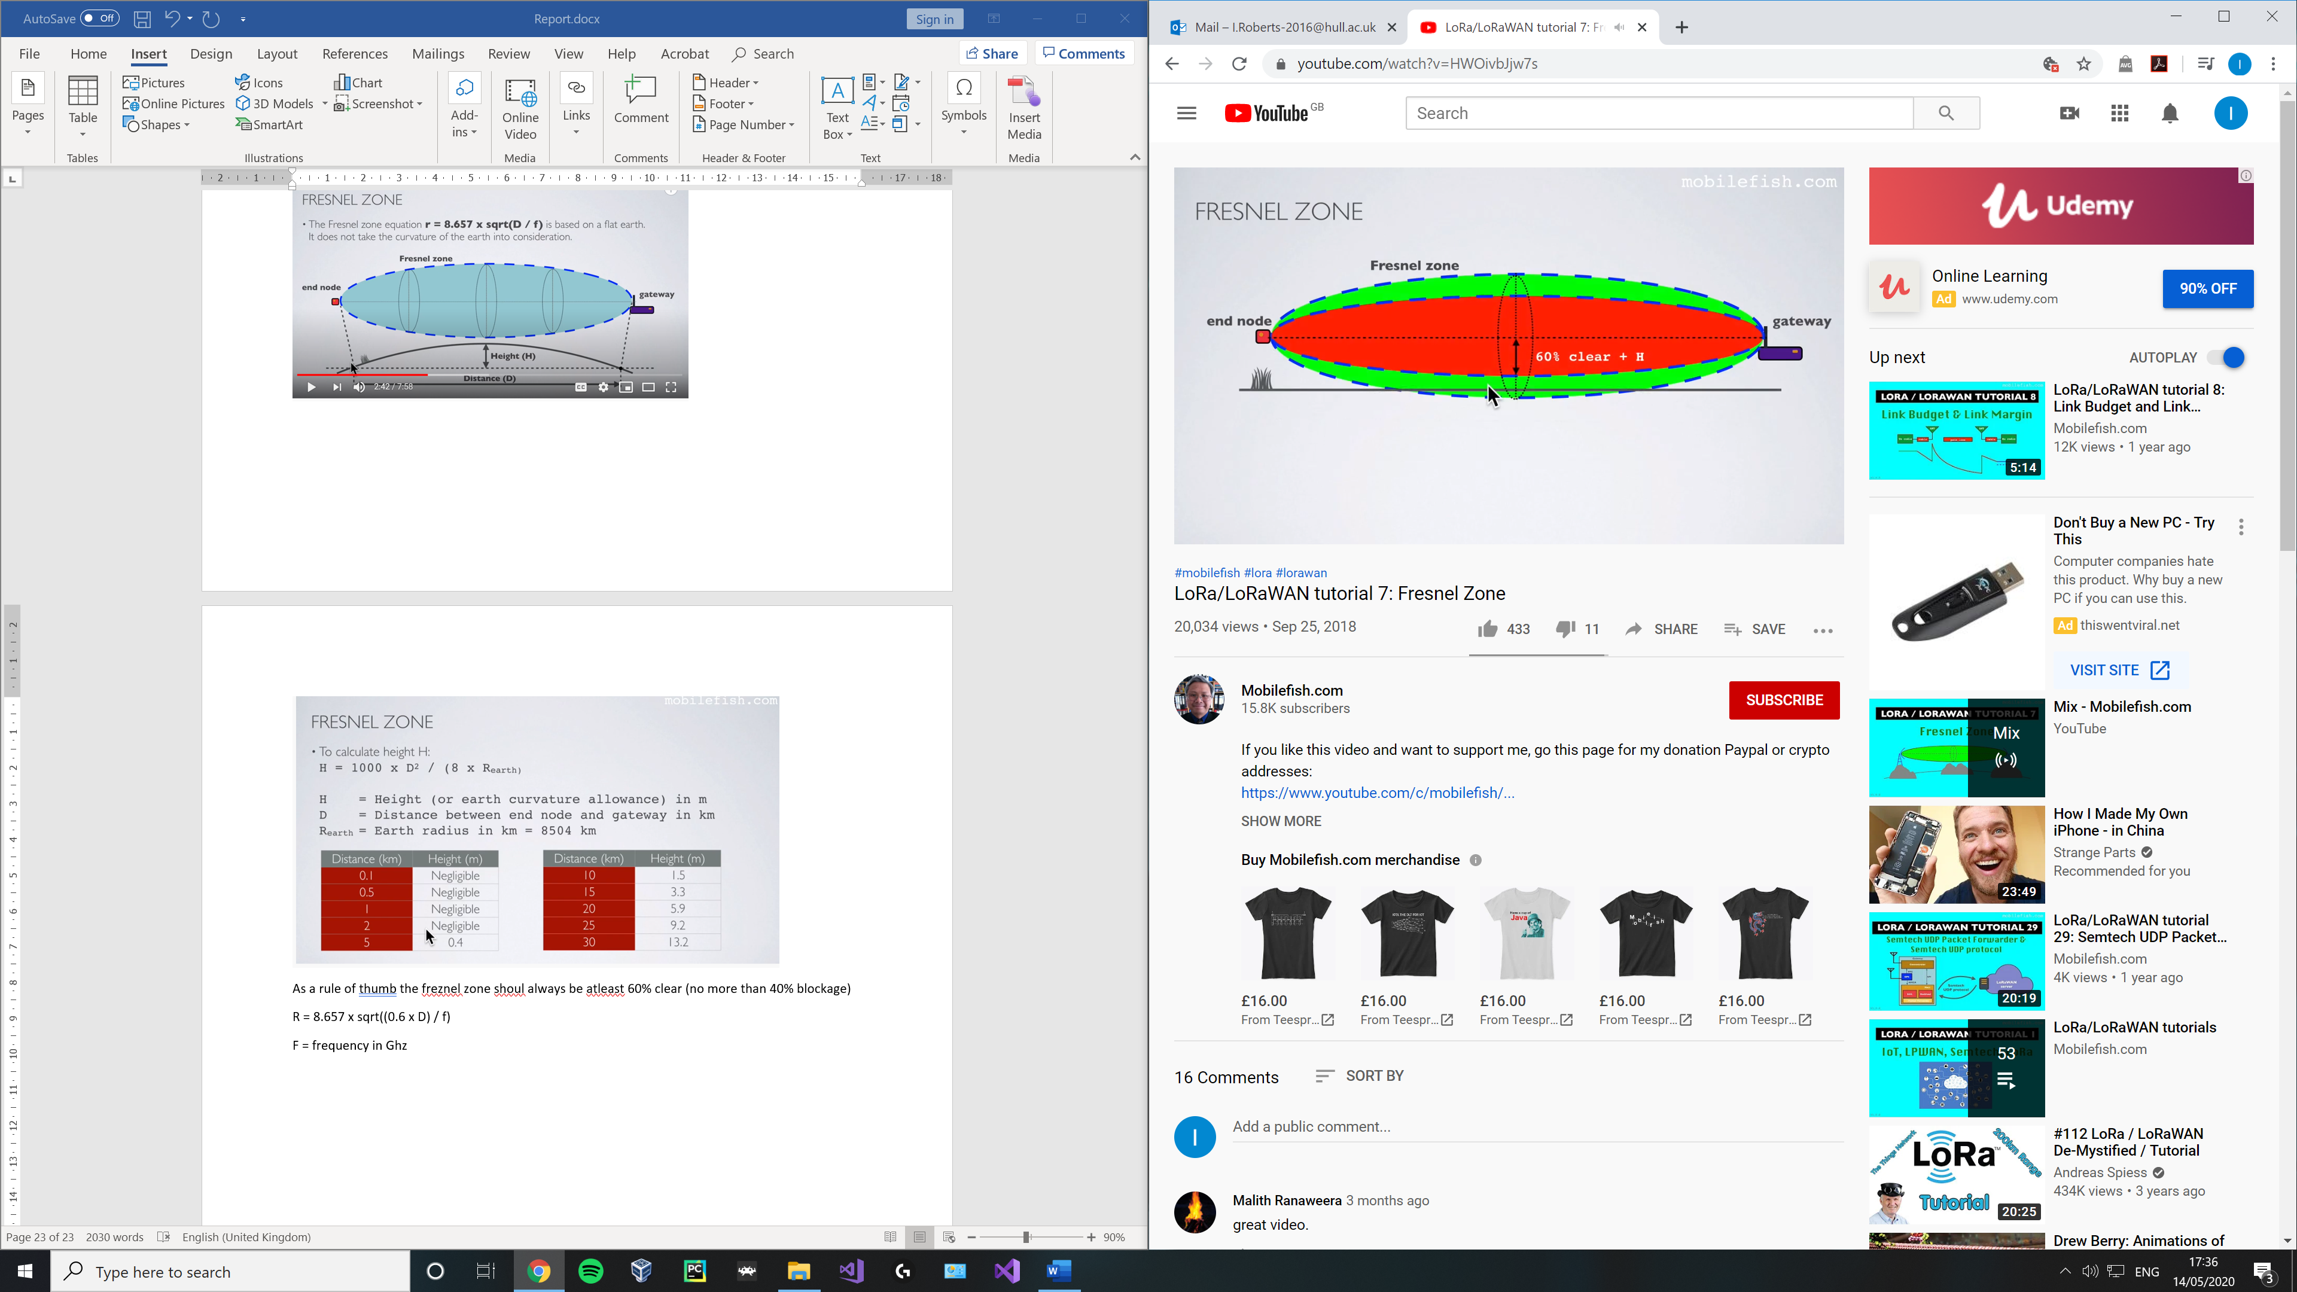

e.g. for a distance of 10 km you need the end node and gateway to be positioned at height of at least 30 m if you don’t want the ground to interfere with your direct signal, if less than 30 ground will interfere.

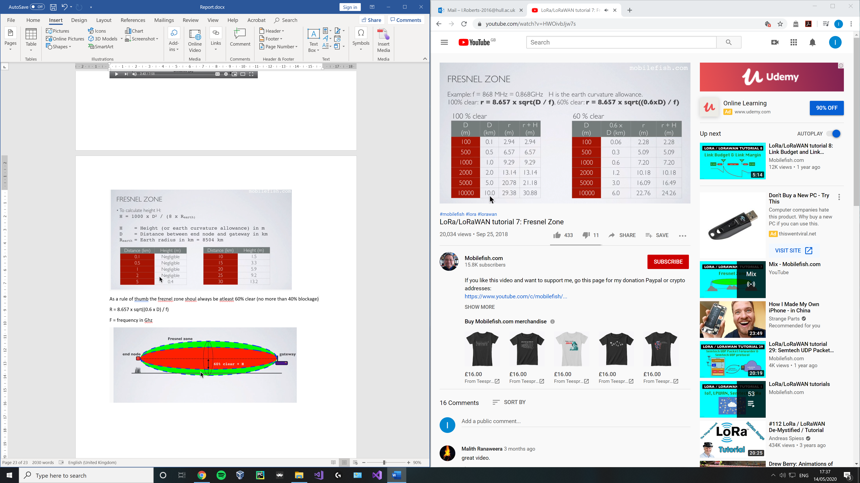

Improve radio signal and performance

* The gateway antenna must be placed outdoors atr a high location (avoiding obsticles in the Fresnel zone)
* Antenna design should be optimized for regional frequency for both gateways and end nodes
* Keep antenna polorisation verticle for both gateway and end nodes and use omnidirectional antenna to cover a large area.

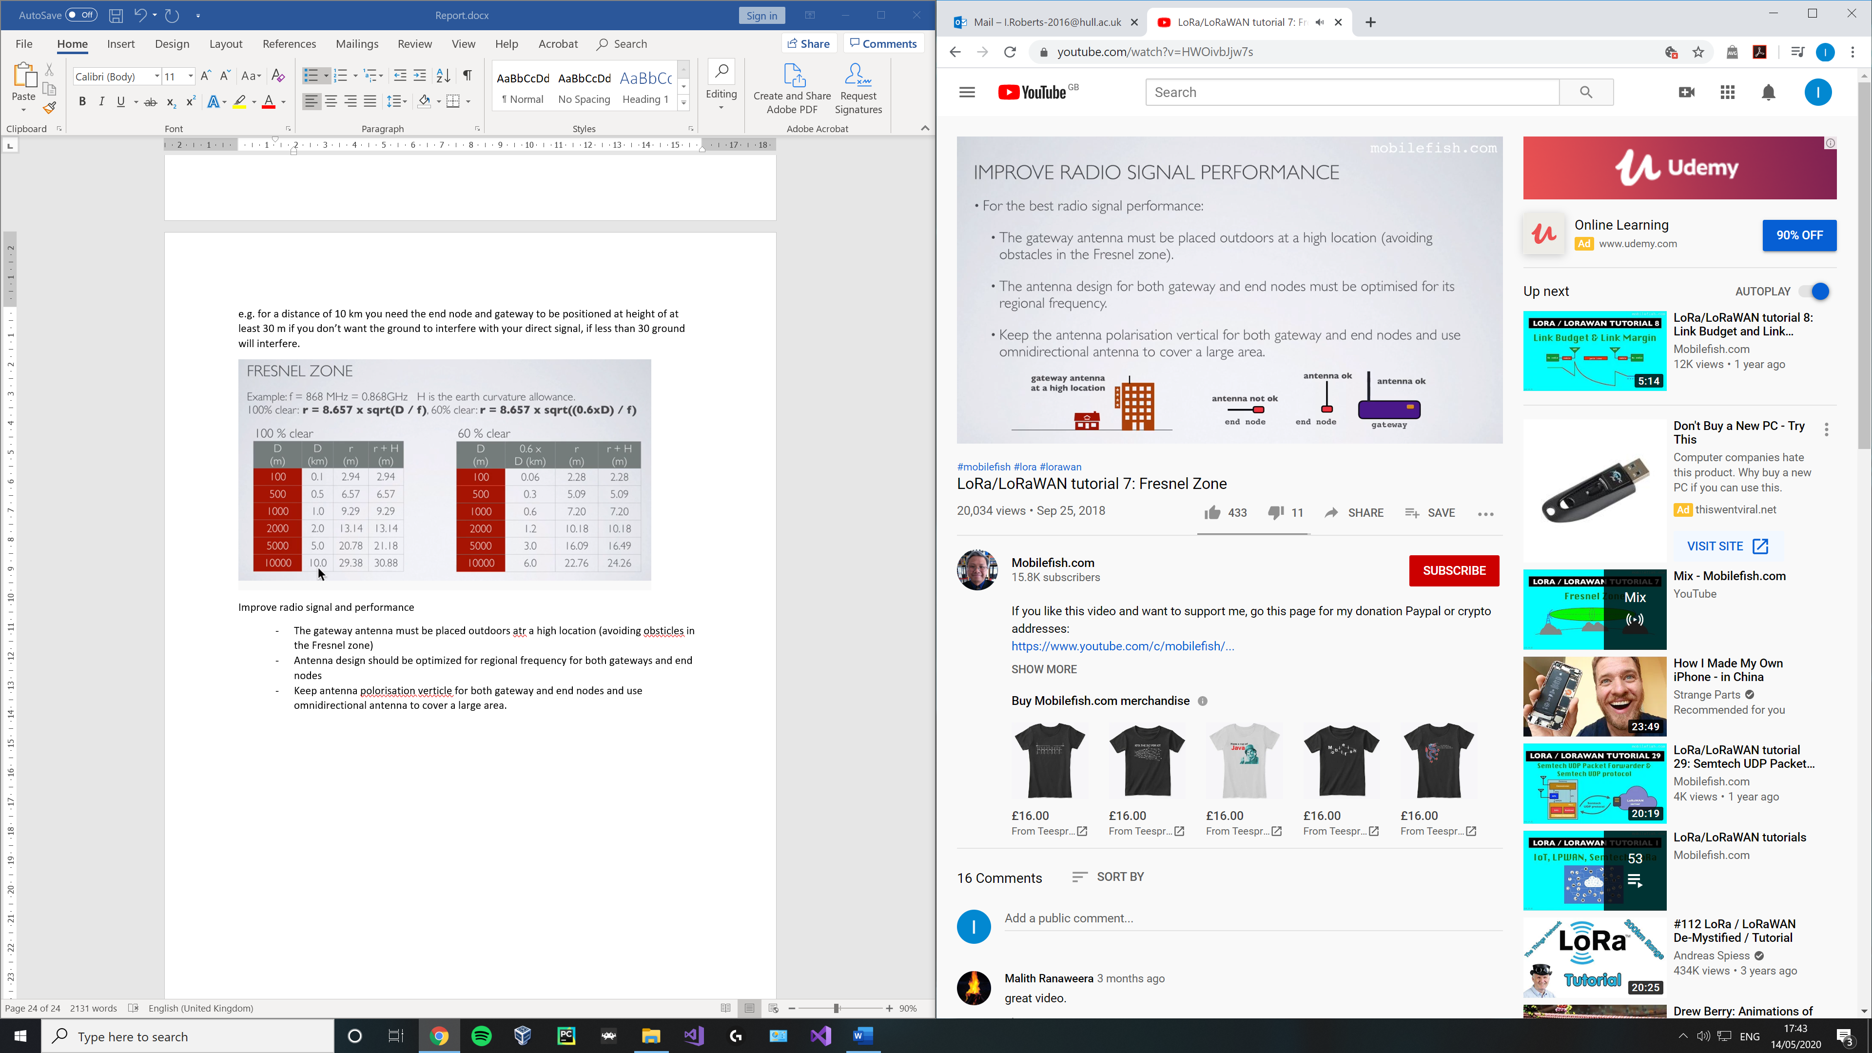

Mobile fish 8 Link budget and link margin

* If a link signal is imposed onto a carrier signal this process is called modulation, signal broadcast to the receiver
* Demodulation is the opposite, signal is recovered from the modulated carrier wave.

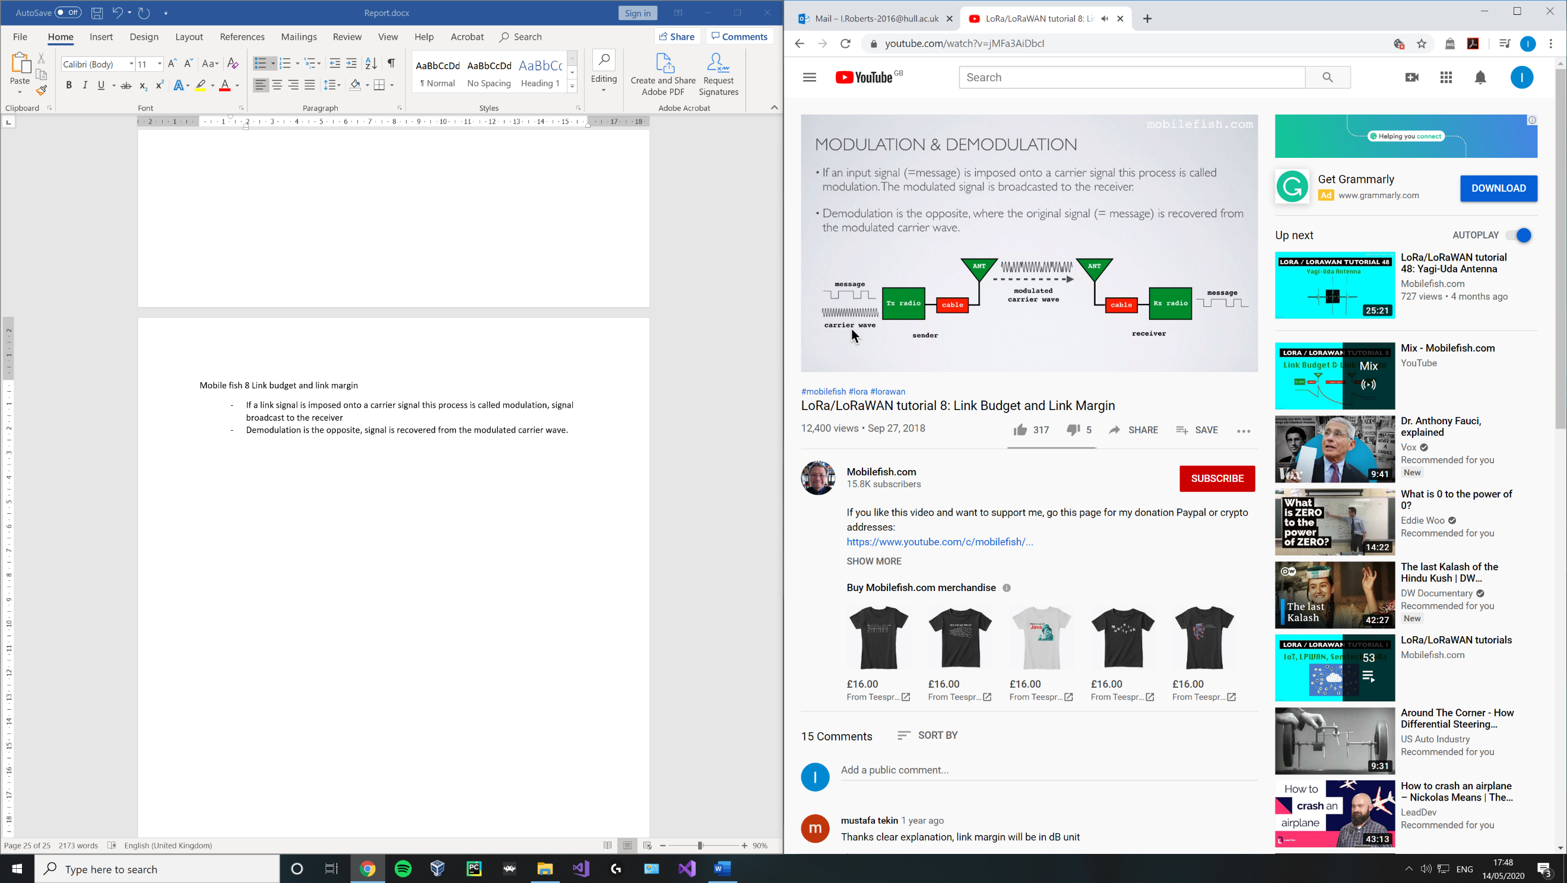

Link budget is a sum of all the gains and losses from the transmitter through the medium to the reciver in a telecommunications system. It is a way of quantifying the link performance.

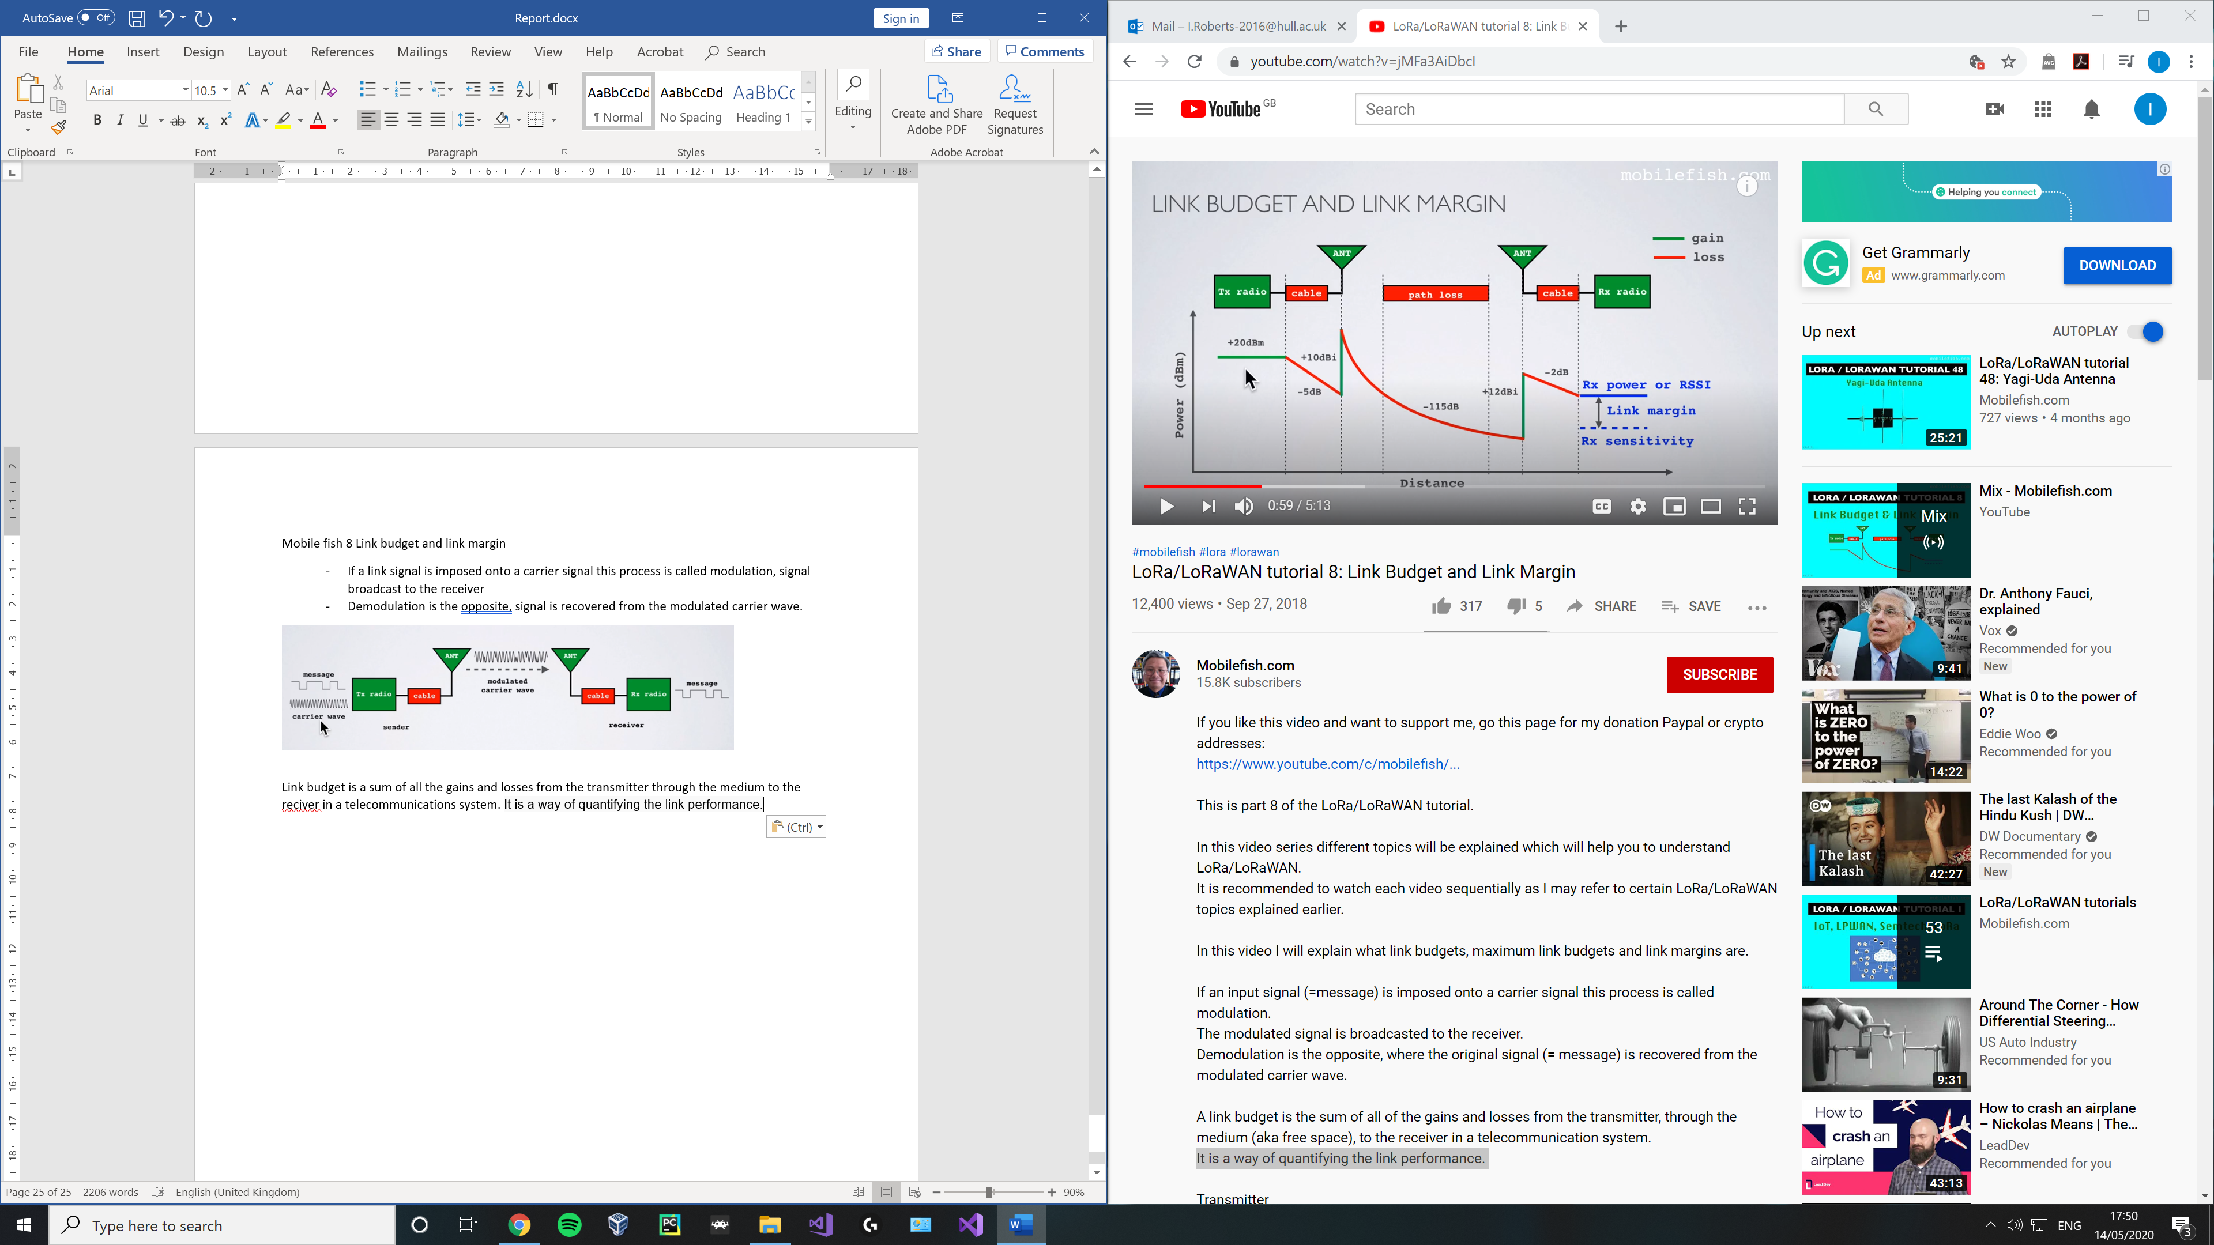

Well-designed antennas usually increase the signal strength.

Received Power = Transmitted Power + Gains − Losses For example: Received Power = 20 - 5 + 10 - 115 + 12 - 2 = -80 dBm

Rx sensitivity is the lowest power level at which the receiver can receive or demodulate the signal.

The link margin is the difference between the received power and receiver sensitivity. Link margin = Received power - Receiver sensitivity Link margin in dBm Received power in dBm Receiver sensitivity in dBm

For example: Received power = -80dBm Receiver sensitivity = -90 dBmLink margin = -80 - (-90) = 10 dBm = 10 mW

Lower sensitivity is better since it can demodulate a receiver frequency at a lower power level.

The link margin must be positive (power > sensitiy) and should gbe atleast a few dB for the receiver to succesfully cdemodulate the signal.

Lora recievers are very sensitive (down to -148) due to the use of chirp spread spectrum.

The maximum link budget can be used as a baseline value to compare one radio to the next. Maximum link budget = Maximum transmitter power - Lowest receiver sensitivity

Maximum link budget in dBm

Maximum transmitter power in dBm

Lowest receiver sensitivity in dBm

For example: Max transmitter power = 20 dBm [2]

Lowest receiver sensitivity = -148 dBm [2]

Max link budget = Max transmitter power - Lowest receiver sensitivity

Max link budget = 20 - (-148) = 168 dBm [2]

Mobile fish 9 EIRP and erp

EIRP = total power radiated by an isotropic antenna in a single direction

Transmission power - cable loss + antenna gain

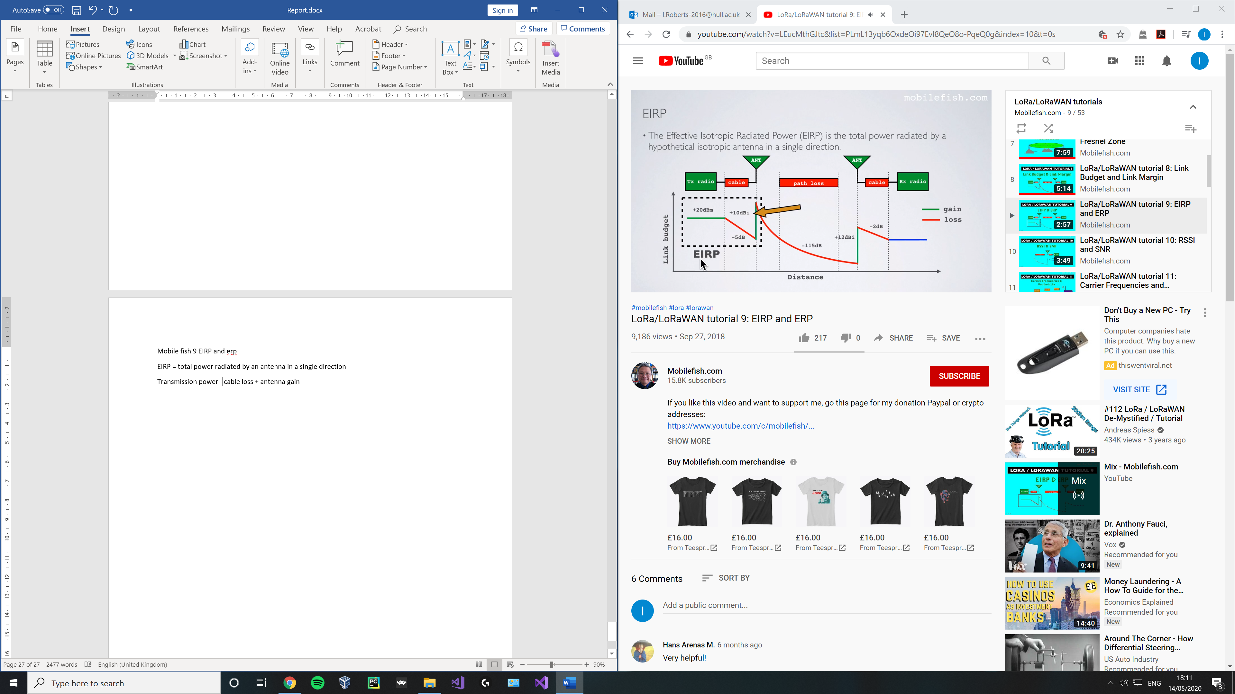

20 -5 + 10 = 25 dbm

Erp is the total power radiated by an actual antenna relative to a half wave dipole rather than a theoretical isotropic antenna

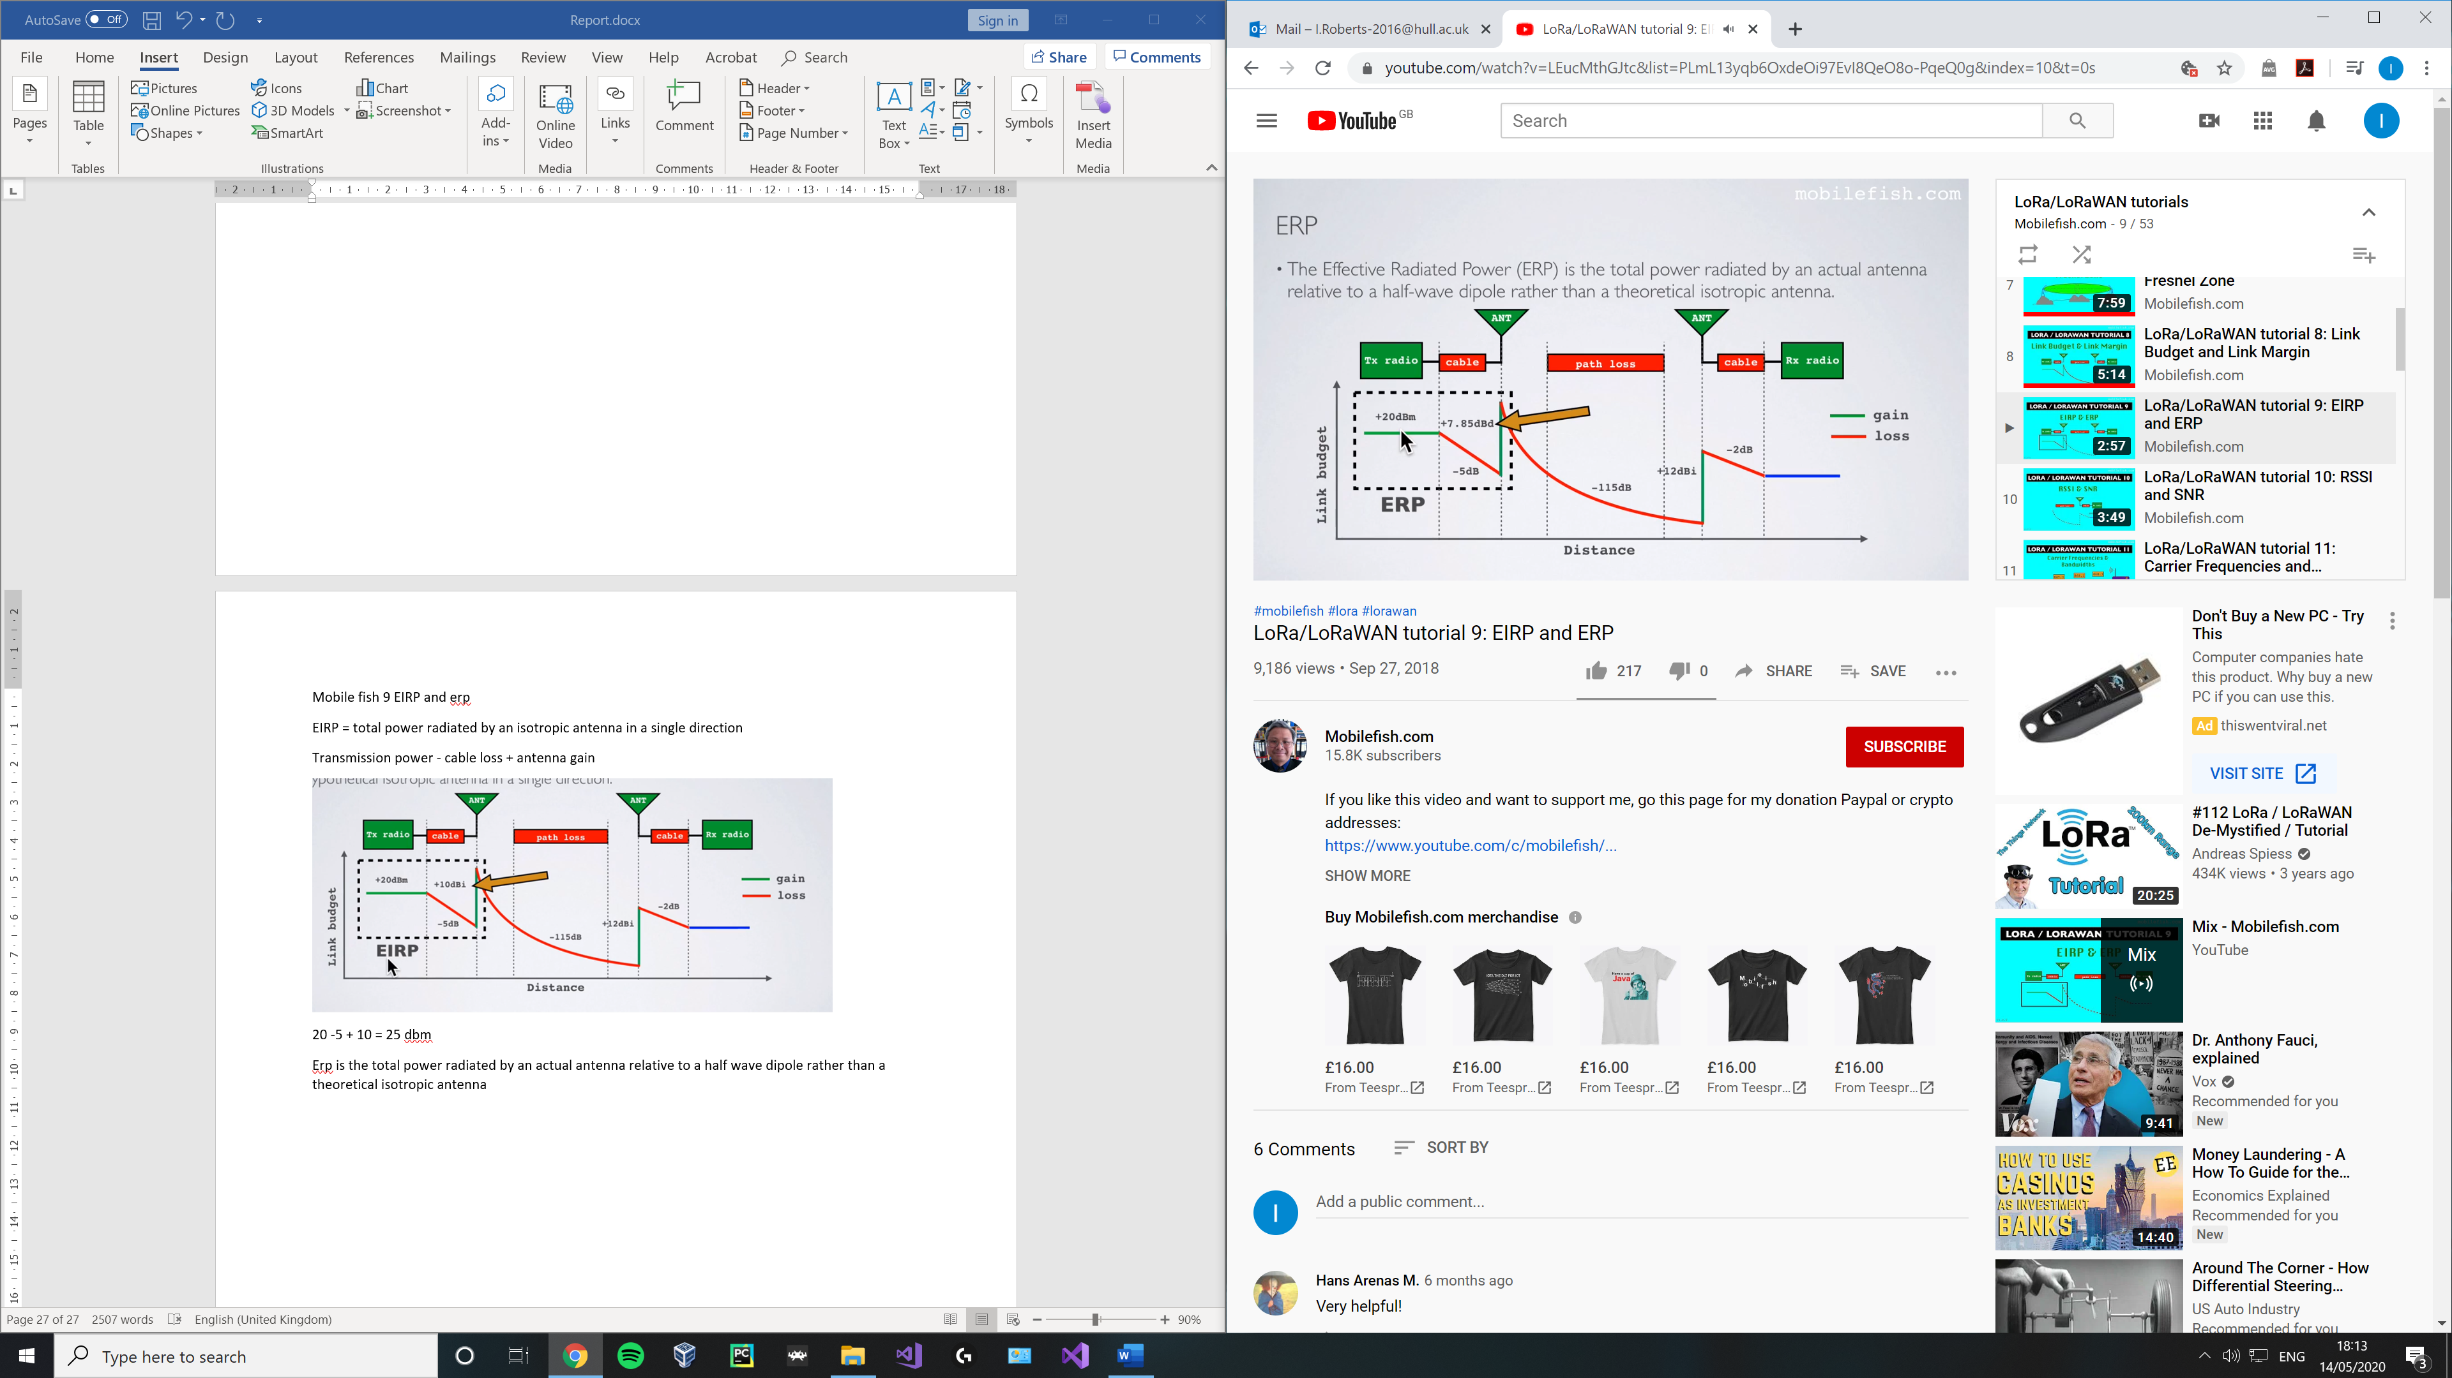

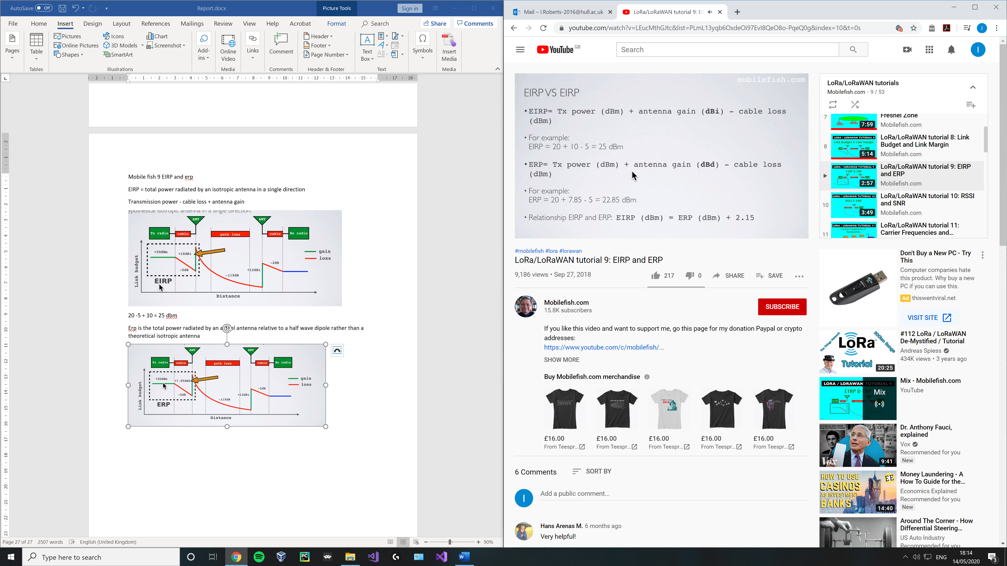

Notice antenna gain expressed in either dbi or dbd

Purpose of eirp and erp:

Rf transmitting systems must adhere to certain rules set by the regulatory bodies such as fcc or etsi

Radio devices must not exceed a certain erp or eirp value set by these bodies.

Mobile fish 10 Rssi and snr

Mobile fish 17 Lora packet format

3 parts:

* Preamble
* Header (payload length, cr (forward error correctional rate), cyclic redundancy check)
* Payload
* Optional payload reducancy check may be appended

2 modes:

* Explicit header mode (header supplied ) [deafult]
* Implicit header mode (header not supplied, smaller packet, payload length and CR must be manually configured on both sides of radio link)

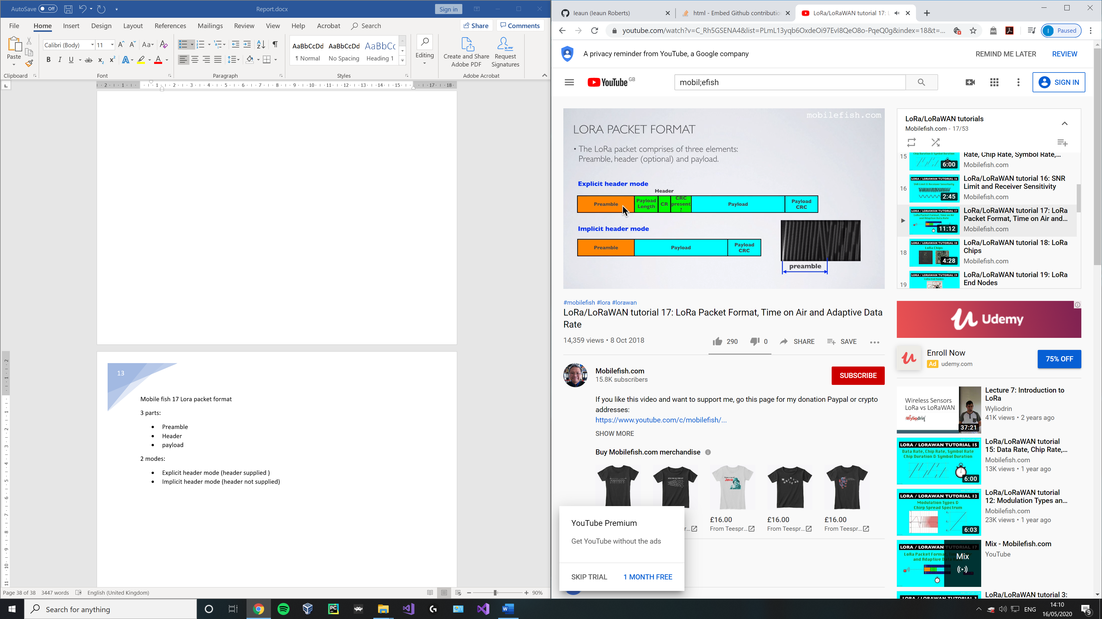

Time on air = Tpacket = Tpreamble + Tpayload

Preamble duration (Tpreamble) in sec

Tpreamble = (npreamble + 4.25) Ts

Number of preambles

For 868: npreamble = 8 symbols

Symbol duration (Ts) in sec

Tpreamble = (8 + 4.25) Ts

**Unfinished**

Payload duration (Tpayload) in sec

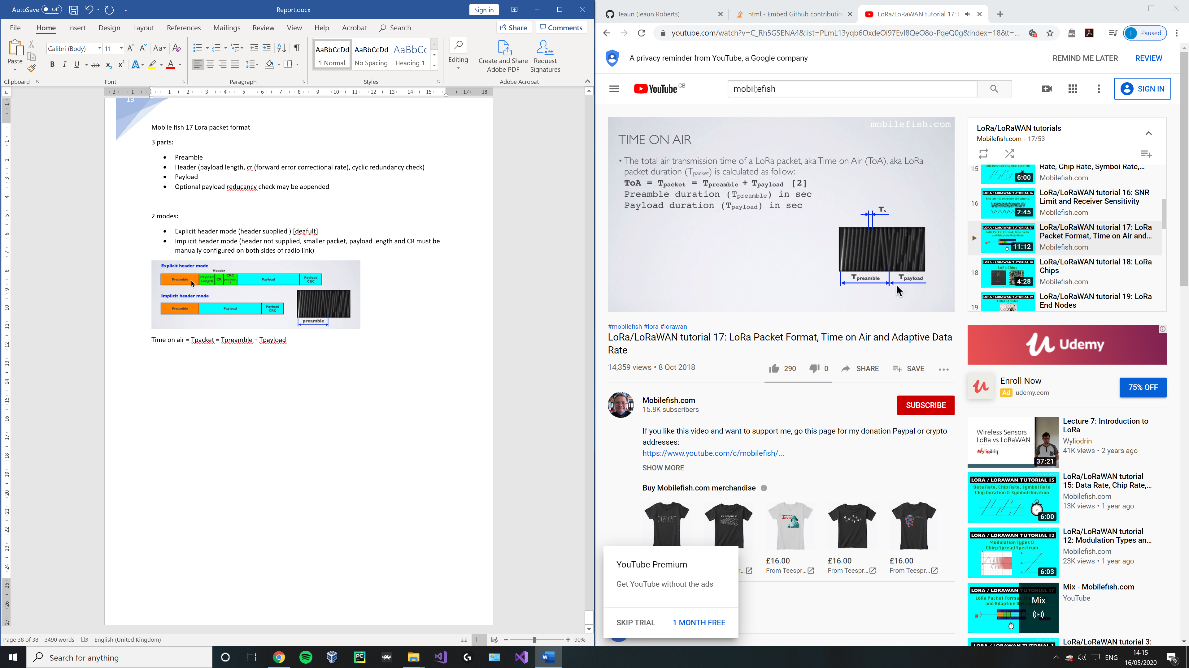

# References

Antratek, 2020. *www.antratek.com.* [Online]   
Available at: https://www.antratek.com/10-channel-lorawan-gateway-4g  
[Accessed 2020].

Cola, P., 2018. *linkedin.com.* [Online]   
Available at: https://www.linkedin.com/pulse/ip-over-lorawan-philippe-cola  
[Accessed 05 2020].

dragino, 2019. *dragino.com.* [Online]   
Available at: https://www.dragino.com/products/module/item/102-lora-shield.html  
[Accessed May 2020].

electronicspecifier, 2020. *electronicspecifier.com.* [Online]   
Available at: https://www.electronicspecifier.com/news/analysis/managing-power-in-the-iot-with-cellular-lpwan-technology  
[Accessed 05 2020].

EMMA GOOD, F. J., 2018. *Evaluating LoRaWAN for IoT applications by developing a wireless parking space monitoring sensor,* STOCKHOLM, SWEDEN: KTH ROYAL INSTITUTE OF TECHNOLOGY.

semtech, n.d. *semtech.com.* [Online]   
Available at: https://www.semtech.com/products/wireless-rf/lora-transceivers/sx1272  
[Accessed 05 2020].

Seneviratne, P., 2019. *Beginning Lora Radio networks with arduino.* 1st ed. s.l.:Apress.

Skrypt, 2019. *hackaday.io.* [Online]   
Available at: https://hackaday.io/project/164242-skrypt  
[Accessed May 2020].

Supply, P., n.d. *uk.pi-supply.com.* [Online]   
Available at: https://uk.pi-supply.com/products/rak811-lora-lorawan-tracker-board-wireless-remote-positioning-solution-max-7q-gps-module-mems-sensor  
[Accessed 13 05 2020].

TTN, 2017. *thethingsnetwork.org.* [Online]   
Available at: https://www.thethingsnetwork.org/article/ground-breaking-world-record-lorawan-packet-received-at-702-km-436-miles-distance  
[Accessed 05 2020].

Wiki, 2020. *wikipedia.org/wiki/LoRa.* [Online]   
Available at: https://en.wikipedia.org/wiki/LoRa  
[Accessed 2020].